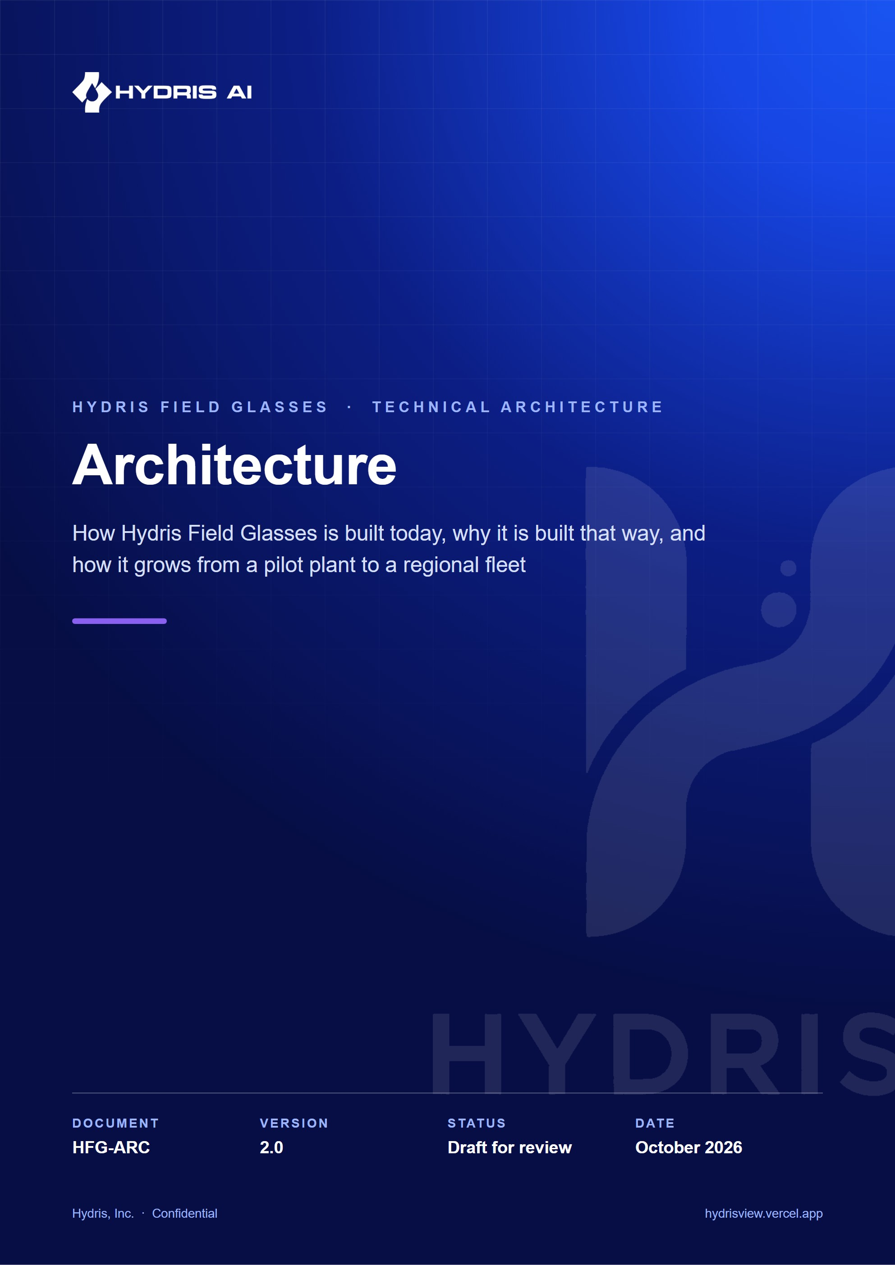
Document control
Document | Architecture (HFG-ARC)
Version | 2.0
Status | Draft for review
Owner | Engineering, Hydris
Audience | Engineering, security reviewers, solution architects, pilot customer IT and OT teams, leadership
Product | Hydris Field Glasses: website, operator console, glasses app, Android app, API
Source of truth | docs/product/ARCHITECTURE.md in tarun-km/hydrisview (this Word file is generated from it)
Classification | Confidential: Hydris, Inc. and named partners
Revision history
Version | Date | Author | Changes
2.0 | October 2026 | Engineering, Hydris | Expanded edition with C4 views, sequence and state diagrams, deployment topologies, ADRs, quality tactics, capacity estimates and a technical debt register

Contents
1 Architectural drivers 5
1.1 Business goals and constraints 5
1.2 Architecture principles 6
2 System context 7
2.1 Context diagram 7
2.2 Actors and external systems 7
3 Containers 9
3.1 Container diagram 9
3.2 Repository layout 10
4 API: a modular monolith 11
4.1 Component view 11
4.2 Request lifecycle 12
4.3 Error contract 13
5 Domain model 14
5.1 Key domain types 14
5.2 Alarm state machine 15
6 Data architecture and tenancy 16
6.1 Schema overview 16
6.2 Row-level security 16
6.3 Append-only records and provenance 18
6.4 Migrations 18
7 Identity, sessions and tokens 19
7.1 Token model 19
7.2 Refresh rotation and reuse detection 20
7.3 Session and token states 21
7.4 Principals and permissions 21
8 Devices and pairing 22
8.1 Pairing flow 22
8.2 Device lifecycle 24
8.3 Glasses UI profiles 25
9 Telemetry and alarms 26
9.1 Ingestion and alarm raising 26
9.2 Stale-data alarms and background jobs 26
10 Realtime 28
10.1 Server-Sent Events 28
11 Audit document scanning 30
11.1 Pipeline 30
11.2 Document states 31
12 Voice assistant 33
13 Client applications 34
13.1 Web application 34
13.2 Android app: Hydris Field 35
14 Deployment topologies 38
14.1 All on Vercel (serverless) 38
14.2 Self-hosted and plant edge 39
14.3 Hybrid 40
14.4 Demo mode and cross-instance state 41
15 Cross-cutting concerns 43
15.1 Caching and concurrency 43
15.2 Error handling and resilience 43
15.3 Observability 44
15.4 Security architecture summary 44
16 Architecture decision records 45
17 Quality attributes 47
18 Scalability path 48
18.1 Capacity model 48
19 Technical debt register 50
20 Future architecture 52
20.1 Target picture 52
20.2 Planned building blocks 53

This document describes the software architecture of Hydris Field Glasses: the operator console, the glasses heads-up app and simulator, the native Android companion app "Hydris Field", the API and the shared domain logic. It is written against the repository at commit 07cca23 on main. Every statement about the current system names the file it comes from. Where the code and an older document disagree, the code wins and this document follows the code.
The architecture has one organising idea: one tenant-isolated API, one shared domain model, many thin clients. The website, the console, the glasses HUD, the simulator and the Android app all speak the same JSON and Server-Sent Events contract to one Fastify application. That application can run as a long-lived server, as a container, or inside a Next.js route handler on Vercel, without code changes.
15  API modules  Fastify plugins under `apps/api/src/modules` |  | 147  HTTP routes  Including `/api/health`; counted from the route registrations |  | 42  Database tables  `apps/api/src/db/schema.ts`, 9 SQL migrations |  | 4  Deployable units  Web (with built-in API), API container, Android app, WebView bridge

Status labels used throughout:
Table 1. Status labels
Label | Meaning
Built | On main, exercised by tests or the live demo at https://hydrisview.vercel.app
Partial | On main but incomplete, unverified on hardware, or limited to one topology
Planned | Not in the repository. Design intent only

1 Architectural drivers

1.1 Business goals and constraints
The architecture is shaped by a small set of goals that come from the product requirements (PRD.md) and from the environment the product runs in: water and wastewater plants (ETPs, STPs, CETPs) where operators wear gloves, stand on ladders and work far from the control room.
Table 2. Architectural drivers
Driver | What it demands of the architecture | Where it shows up
Read-only to the plant | No write path to PLC, SCADA or DCS. Telemetry is pushed in, never pulled out of control networks | POST /api/ingest/v1/readings only accepts readings (modules/telemetry.ts)
Strict tenant isolation | A missing WHERE clause must not leak another customer's data | Postgres RLS on every tenant table (drizzle/0001_rls.sql, db/tenant.ts)
Hands-free field use | Short, spoken, glanceable interactions; tolerate flaky Wi-Fi | Glasses HUD (apps/web/src/glasses), voice (modules/voice-assistant.ts), offline queue (glasses/link.ts)
Defensible records | Every reading, correction and approval must be attributable and append-only | audit_events, telemetry_corrections, audit_document_events grants
Zero-configuration demo | A prospect opens a URL and gets a live, believable plant | Demo mode (apps/api/src/demo.ts, core/demo-shared.ts)
Small team, fast iteration | One language, one repository, one deployable for most customers | TypeScript monorepo, modular monolith
Hardware churn | Meta glasses SDKs change quickly; the display glasses are not yet broadly available | Device integration isolated behind SecureStore, camera and voice adapters

1.2 Architecture principles
- The API is the product boundary. Clients hold no business rules that the API does not also enforce. packages/domain/src/roles.ts says it plainly: the matrix is the single source of truth, "the API enforces it on every request and clients only use it to decide what to show".
- Pure logic lives in packages/domain. State machines, threshold evaluation, unit normalisation, OCR structuring and UI profile resolution have no I/O and are unit-tested in isolation.
- Defence in depth for tenancy. Role checks in handlers, site scoping in queries, and row-level security in the database. Any one layer failing does not expose data.
- One ingestion path. Gateways, manual entry, laboratory entry and the simulator all go through ingest() in modules/telemetry.ts. Alarms cannot be raised by a side door.
- Runtime portability. The same buildApp() (apps/api/src/app.ts) runs under server.ts (long-lived), serverless.ts (Vercel) and the test harness.
- Events are hints, the database is truth. Realtime events tell clients what to refetch. Losing or duplicating one never corrupts state.

2 System context

2.1 Context diagram
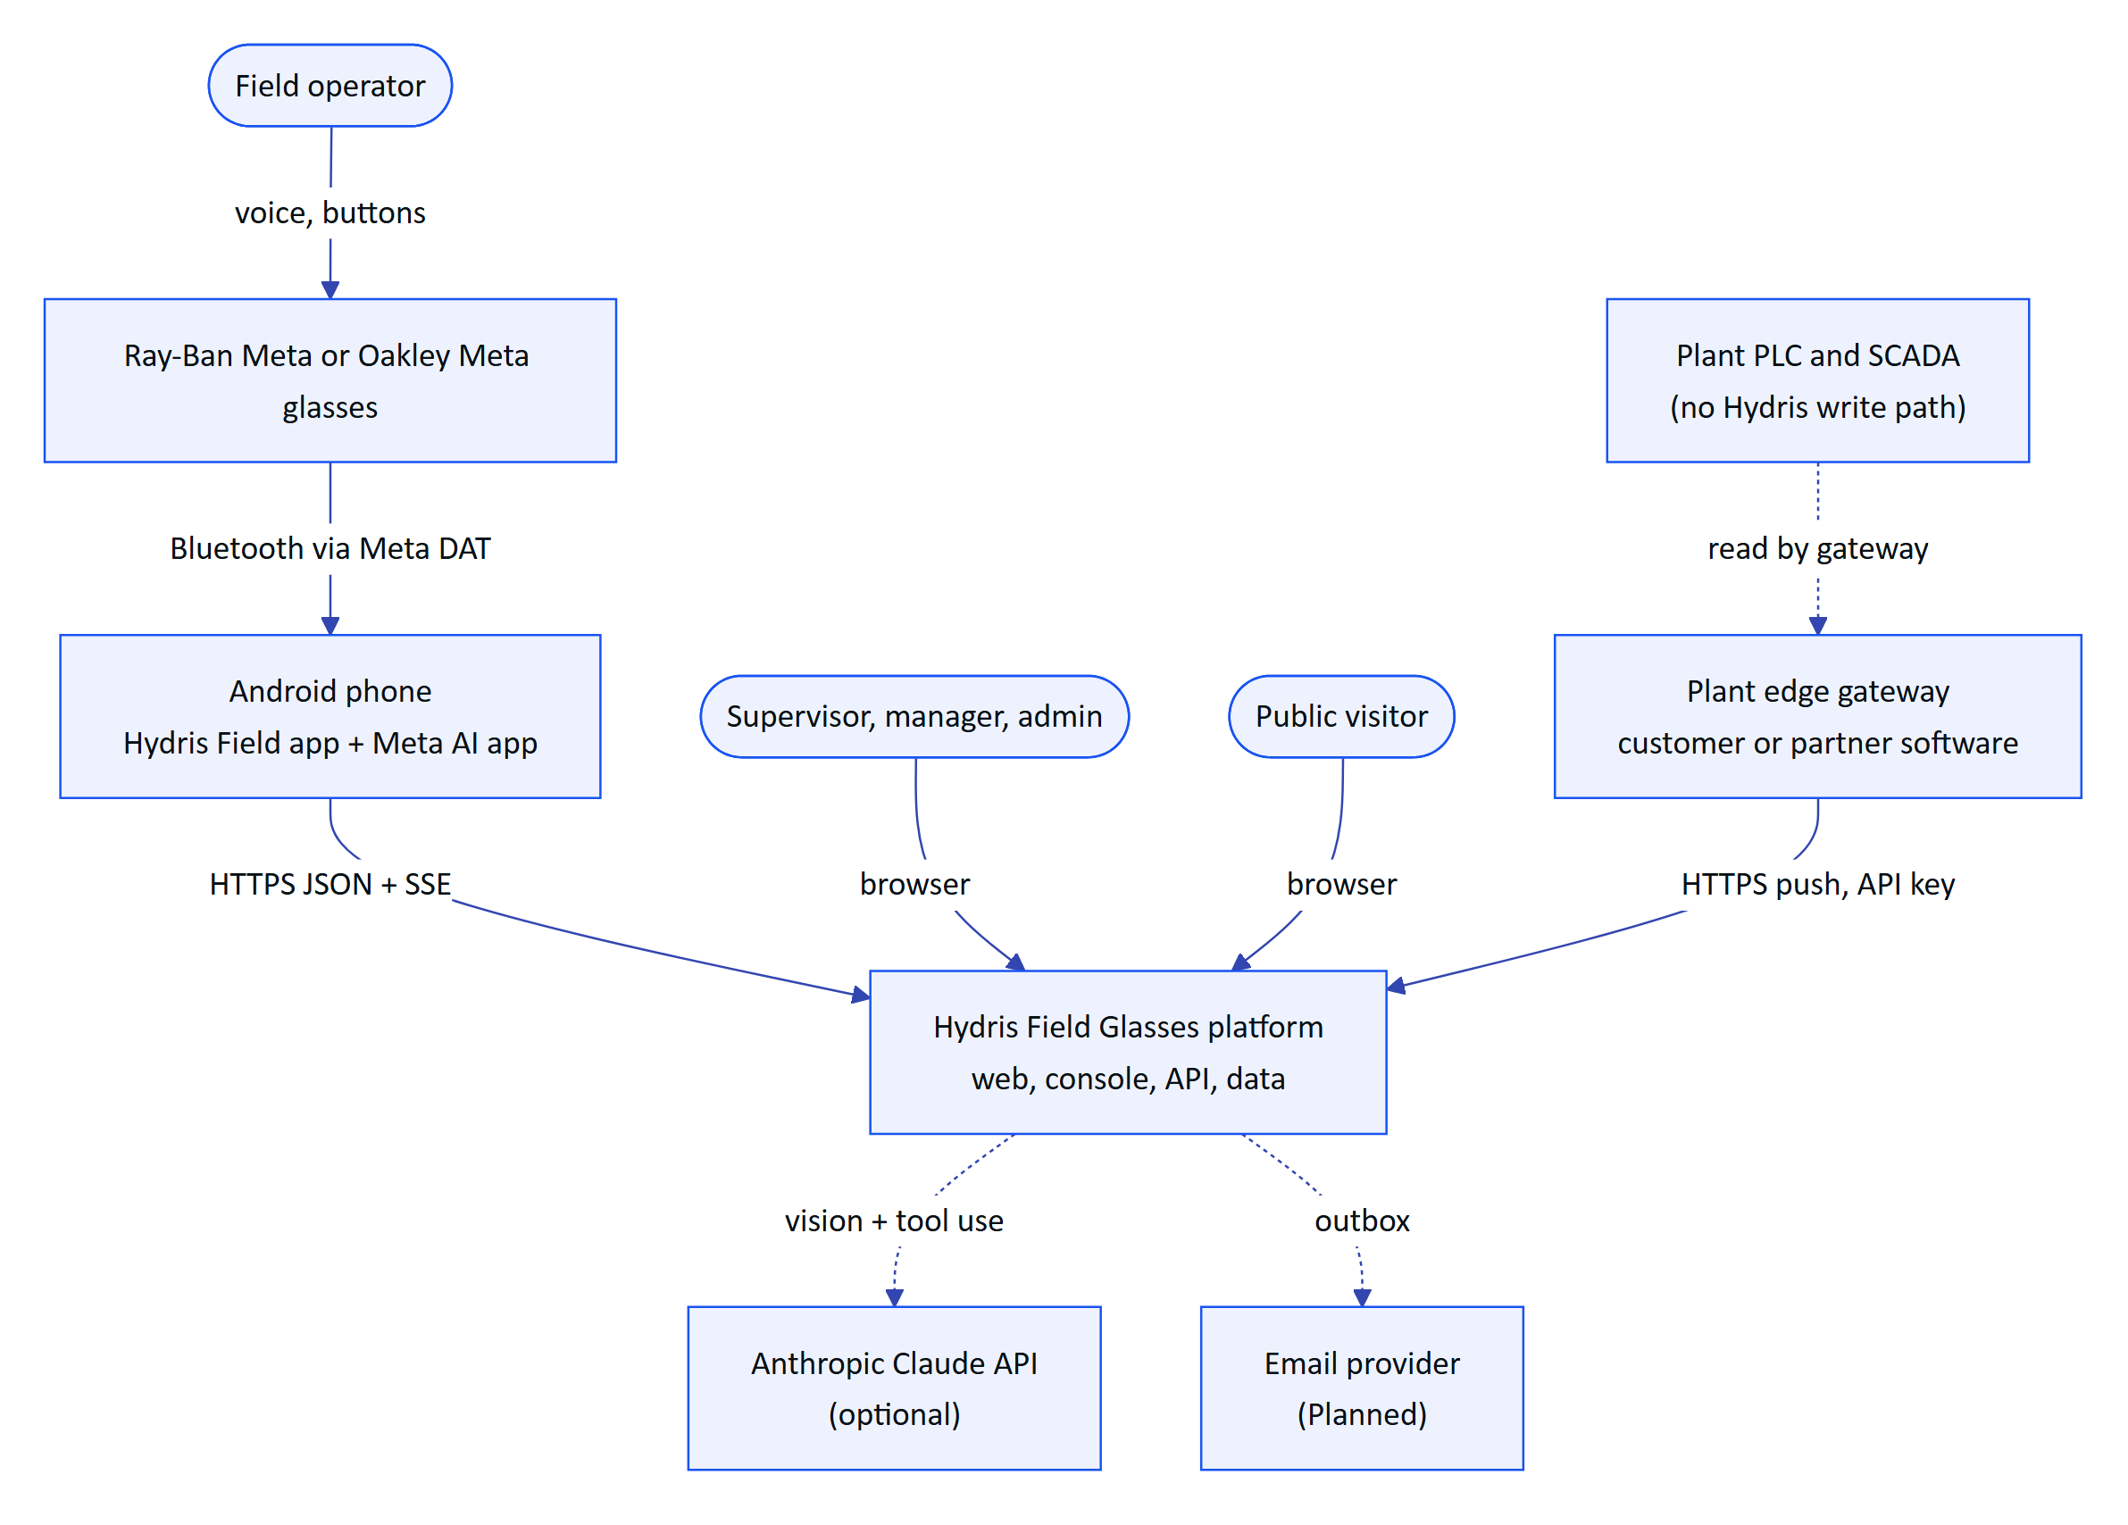
Figure 1. System context (C4 level 1). Hydris sits beside the plant control system, never inside it.

2.2 Actors and external systems
Table 3. Actors and external systems
Element | Kind | Interaction | Status
Field operator | Person | Glasses HUD, Android app, voice | Built (web HUD, Android app). Partial on real glasses hardware
Supervisor, maintenance engineer, manager, org admin | Person | Operator console (/console) | Built
Platform admin | Person | /console/platform, /api/platform/organizations | Built
Public visitor | Person | Website, live glasses demo, contact form | Built
Meta glasses | Device | Camera, microphone, capture button through the Meta Wearables Device Access Toolkit (DAT) 1.0.1 | Partial (code complete, limited hardware verification)
Plant edge gateway | System | Pushes readings with a hgw_ key | Built (endpoint). Gateway software itself is Planned
Anthropic Claude API | System | Document vision extraction and voice assistant tool use | Built, optional (enabled by ANTHROPIC_API_KEY)
Email provider | System | Invitations and password reset | Planned. Messages are written to mail_outbox (core/services.ts)

IMPORTANT
Hydris never connects to a PLC, SCADA or DCS and has no endpoint that writes to one. Ingestion is outbound HTTPS from the plant to Hydris. This keeps Hydris outside IEC 62443 control zones and means a compromise of Hydris cannot change the physical process.

3 Containers

3.1 Container diagram
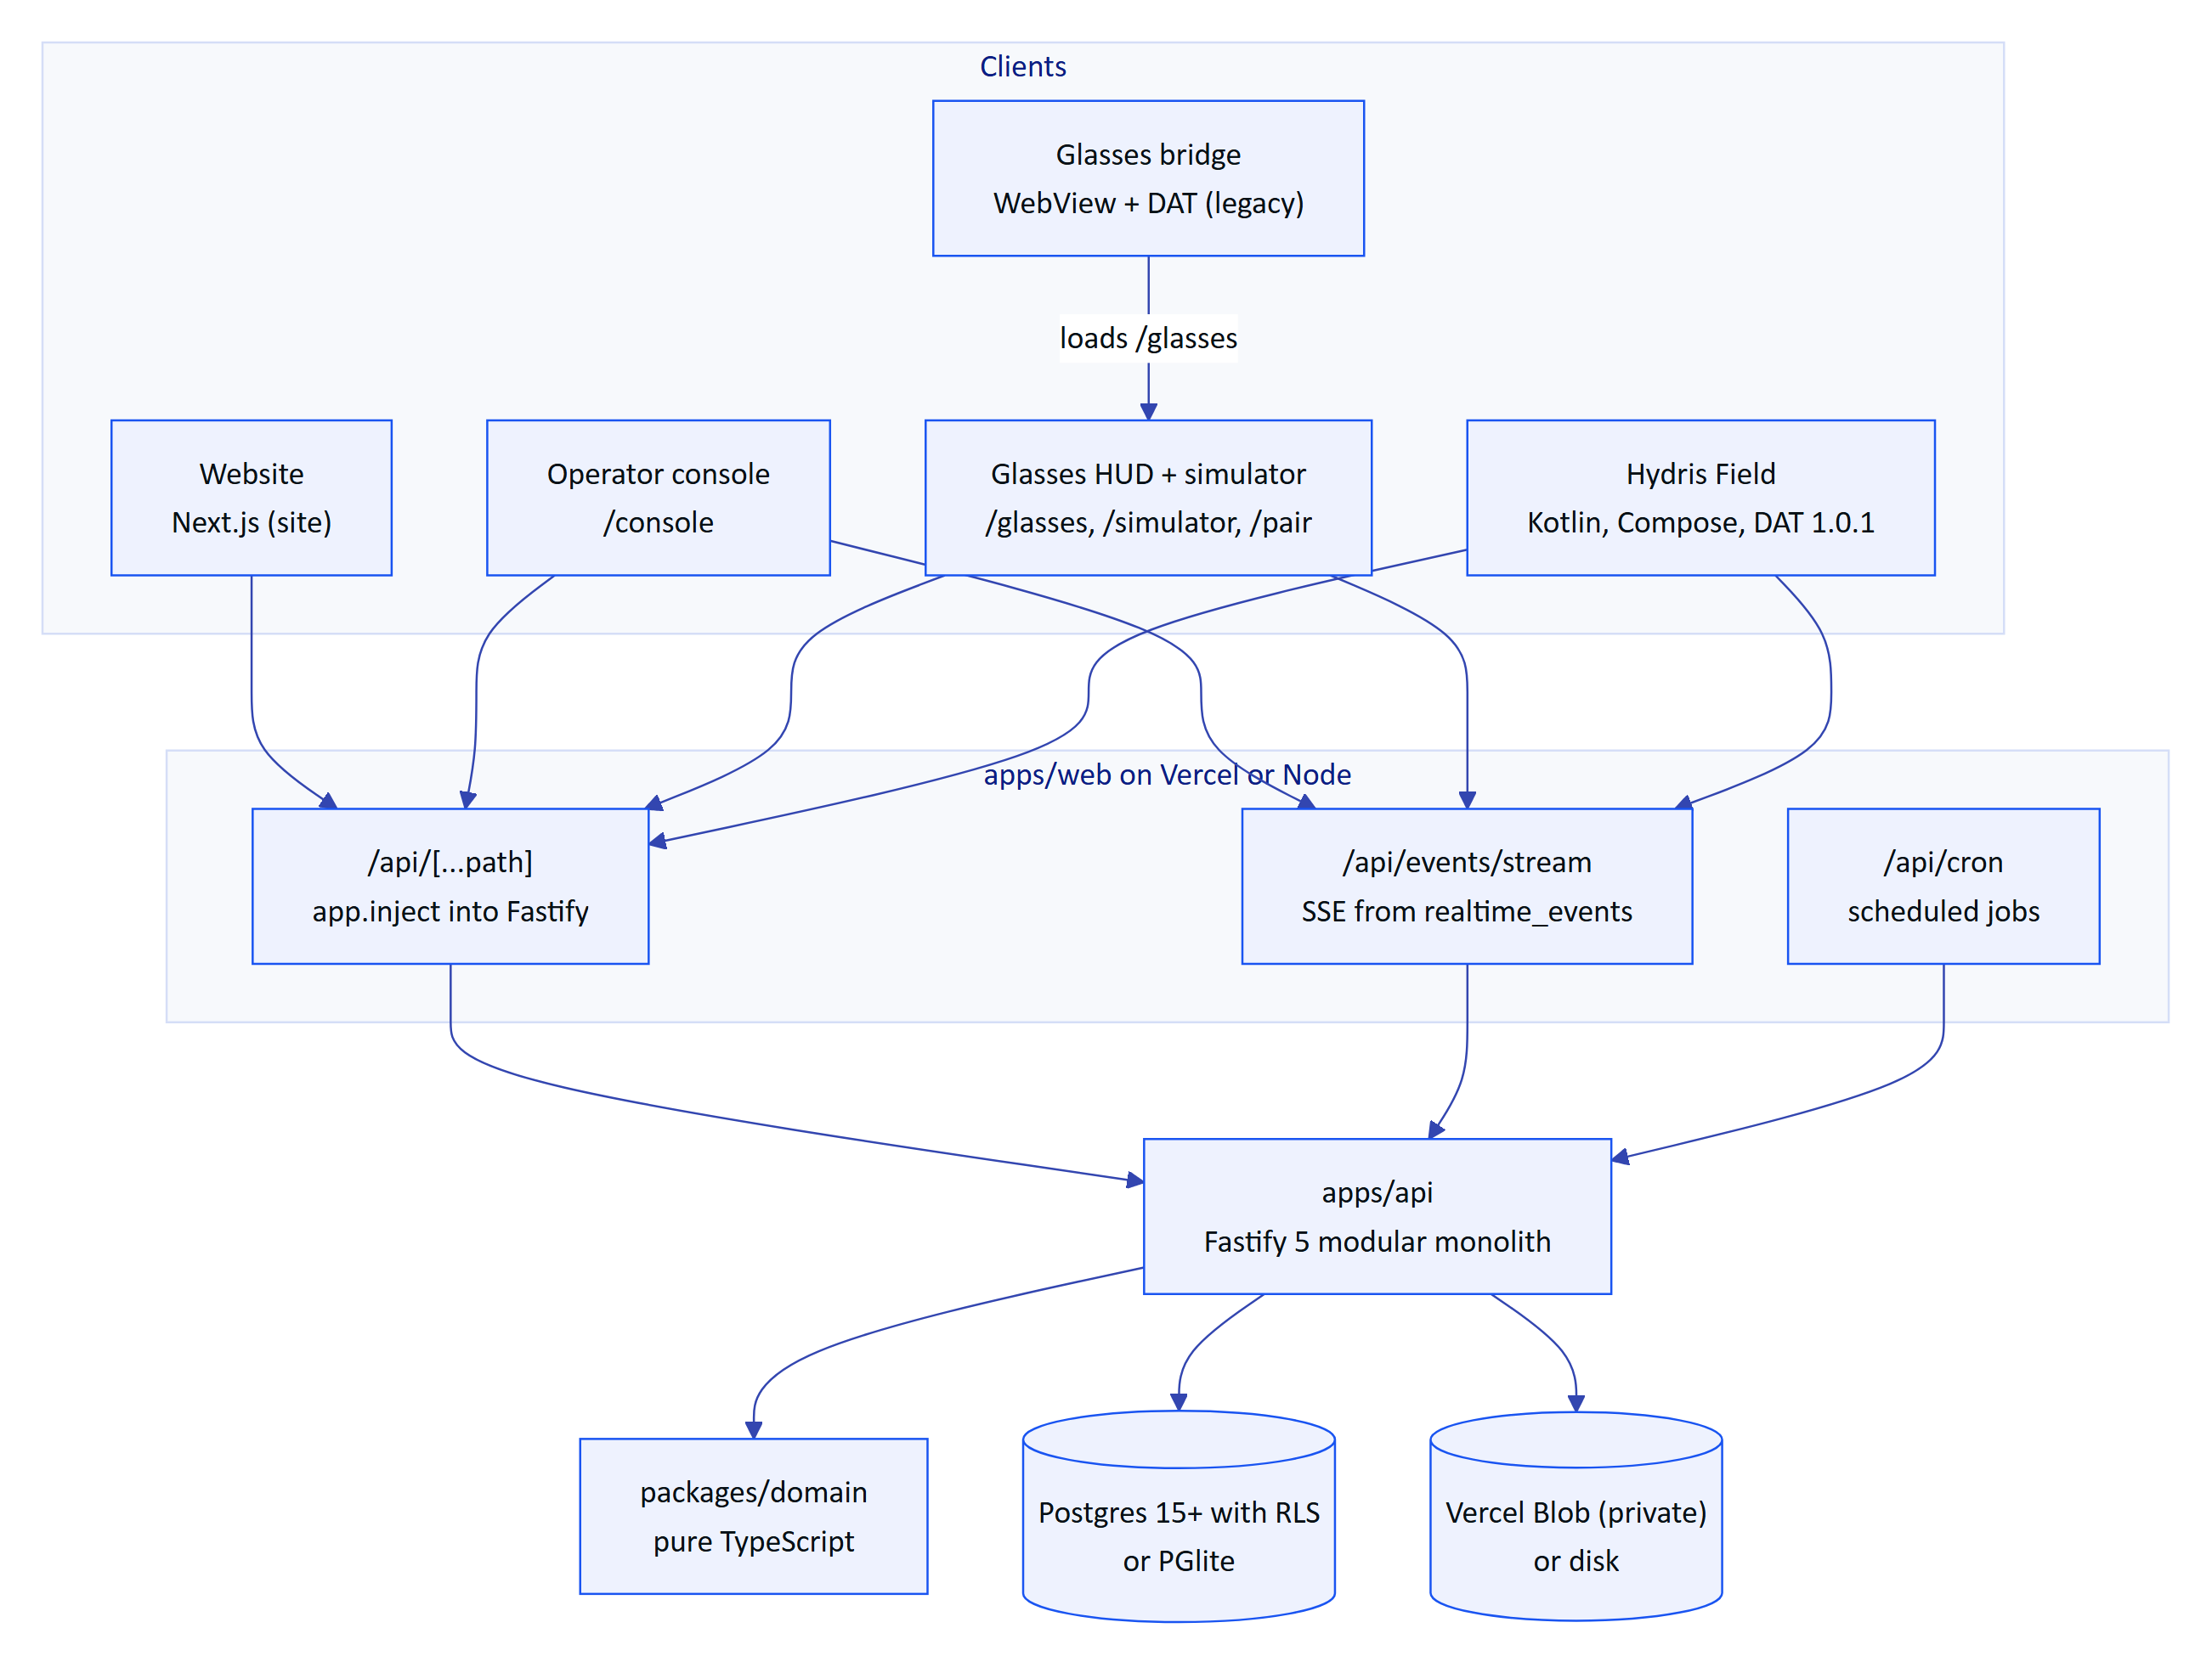
Figure 2. Containers (C4 level 2). The API can run inside the web deployment or as its own container.
Table 4. Containers and technology
Container | Technology (versions from package.json and build.gradle.kts) | Key files | Status
API | Fastify 5.12.7, zod 4.6.7, Drizzle ORM 0.45.4, pg 8.23.1, PGlite 0.5.9, @fastify/jwt, @fastify/rate-limit, @node-rs/argon2, pdf-lib, @anthropic-ai/sdk 0.137.0 | apps/api/src/app.ts, modules/*, core/* | Built
Web | Next.js 16.4, React 19.3, TanStack Query 5, Tailwind 4, Radix UI, Recharts, Tesseract.js 7 | apps/web/src/** | Built
Domain | TypeScript, no runtime dependencies | packages/domain/src/* | Built
Contracts | Placeholder package (export {}) | packages/contracts/src/index.ts | Planned
Hydris Field (Android) | Kotlin, Jetpack Compose (BOM 2026.05.01), OkHttp 4.12, CameraX 1.4.2, ML Kit text recognition 16.0.1, DAT 1.0.1 (core, camera, speech, inputs) | apps/android/app/src/main/java/ai/hydris/field/** | Built (Partial on hardware)
Glasses bridge | Kotlin, Android WebView, DAT 1.0.1 | apps/glasses-bridge-android/.../MainActivity.kt | Partial, superseded by Hydris Field
Database | Postgres 15+ (Neon, Render, Supabase, self-hosted Postgres 17 in Compose) or PGlite in-process | apps/api/drizzle/0000 to 0008 | Built
File storage | Vercel Blob private store or local disk | core/services.ts (createStorage) | Built

3.2 Repository layout
The repository is an npm workspaces monorepo (package.json, "workspaces": ["packages/*", "apps/*"], Node 22.x). The web app depends on the API package directly ("@hydris/api": "0.2.0") and imports @hydris/api/serverless, which is how the API runs inside Next.js.
Table 5. Workspaces
Workspace | Package name | Role
packages/domain | @hydris/domain | Roles, permissions, measurands, alarm and workflow state machines, device lifecycle, UI profiles, audit document structuring, voice parsing, simulation scenarios
packages/contracts | @hydris/contracts | Reserved for shared request and response schemas (empty today)
apps/api | @hydris/api | HTTP API, database schema and migrations, seeds, jobs, demo runtime
apps/web | @hydris/web | Website, console, glasses HUD, simulator, pairing page, built-in API route handlers
apps/android | Gradle project | Native operator app with glasses integration (not an npm workspace member in practice: no package.json)
apps/glasses-bridge-android | Gradle project | WebView companion that bridges DAT into the web HUD

DECISION
One monorepo, one language on the server and web. The API, web and domain packages share TypeScript types without a publishing step, and a change to a state machine lands in one commit across server and clients. The Android app is the exception: it mirrors the JSON contract by hand in Models.kt until packages/contracts produces a schema that Kotlin can consume (see the technical debt register).

4 API: a modular monolith

4.1 Component view
buildApp() in apps/api/src/app.ts creates one Fastify instance, registers shared plugins (helmet, cookie, global rate limit, JWT, multipart), installs the error handler and the glasses UI profile hook, then registers fifteen route modules under the /api prefix. Every module receives the same Ctx (apps/api/src/context.ts): database handle, event bus, configuration, storage adapter and the live-device map.
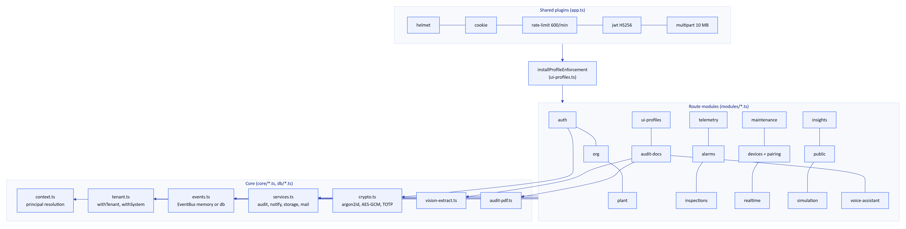
Figure 3. API components (C4 level 3). Modules share the context object and the core services, never each other's tables directly except through exported functions.
Table 6. API modules
Module | Routes | Responsibility | Notable rules
auth.ts | 17 | Login, demo guest login, MFA (TOTP), refresh rotation, logout, invitations, password reset, sessions, org switch | Lockout after 5 failures for 15 min, refresh reuse detection with a 30 s grace
org.ts | 13 | Organization, members, invitations, notifications, audit log, platform organizations | No role escalation (assignableRoles)
plant.ts | 28 | Sites, facilities, process areas, assets, sensors, gateways, documents, attachments, hierarchy, history | Attachments only served through the authorised route
telemetry.ts | 6 | Gateway ingestion, manual and lab entry, downsampled history, CSV export, corrections | Single ingest() path, idempotent on (sensor_id, ts)
alarms.ts | 9 | Alarm rules, alarm list and detail, transitions, stale-data evaluation | Deadband and on-delay, note required to resolve
inspections.ts | 15 | Templates, routes, inspections, step responses, submit and review | Offline replay by clientOpId, revision counter
maintenance.ts | 7 | Work orders, checklists, activity | Transition table in domain/workflows.ts
devices.ts | 16 | Pairing challenges, approval, device refresh, device context, fleet admin | RFC 8628 shape, session version, refresh family revocation
realtime.ts | 1 | GET /api/events/stream (SSE) | Per-connection canReceive authorisation
insights.ts | 4 | Overview KPIs, grounded document assist, search, reports | Read-only
public.ts | 1 | Website contact and demo requests | 5 requests per 10 min
simulation.ts | 3 | Start, stop and inspect demo scenarios | Synthetic data rejected for non-demo tenants
ui-profiles.ts | 13 | Glasses UI profiles, versions, assignments, effective profile | Enforced on device requests by an onRoute hook
audit-docs.ts | 12 | Scanned audit documents: capture, enhance, review, verify, approve, PDF | Four-eyes approval, optimistic concurrency
voice-assistant.ts | 1 | POST /api/assistant/ask | Claude tool use or deterministic rules, 60 per min

Route counts come from the app.get/post/put/patch/delete registrations; devices.ts registers suspend, reactivate and revoke in one loop and is counted as three.

4.2 Request lifecycle
Every authenticated request follows the same path. In the built-in API mode on Vercel, the path starts in a Next.js route handler that forwards the request into Fastify with app.inject (apps/web/src/app/api/[...path]/route.ts), so there is no network hop between the web and the API.
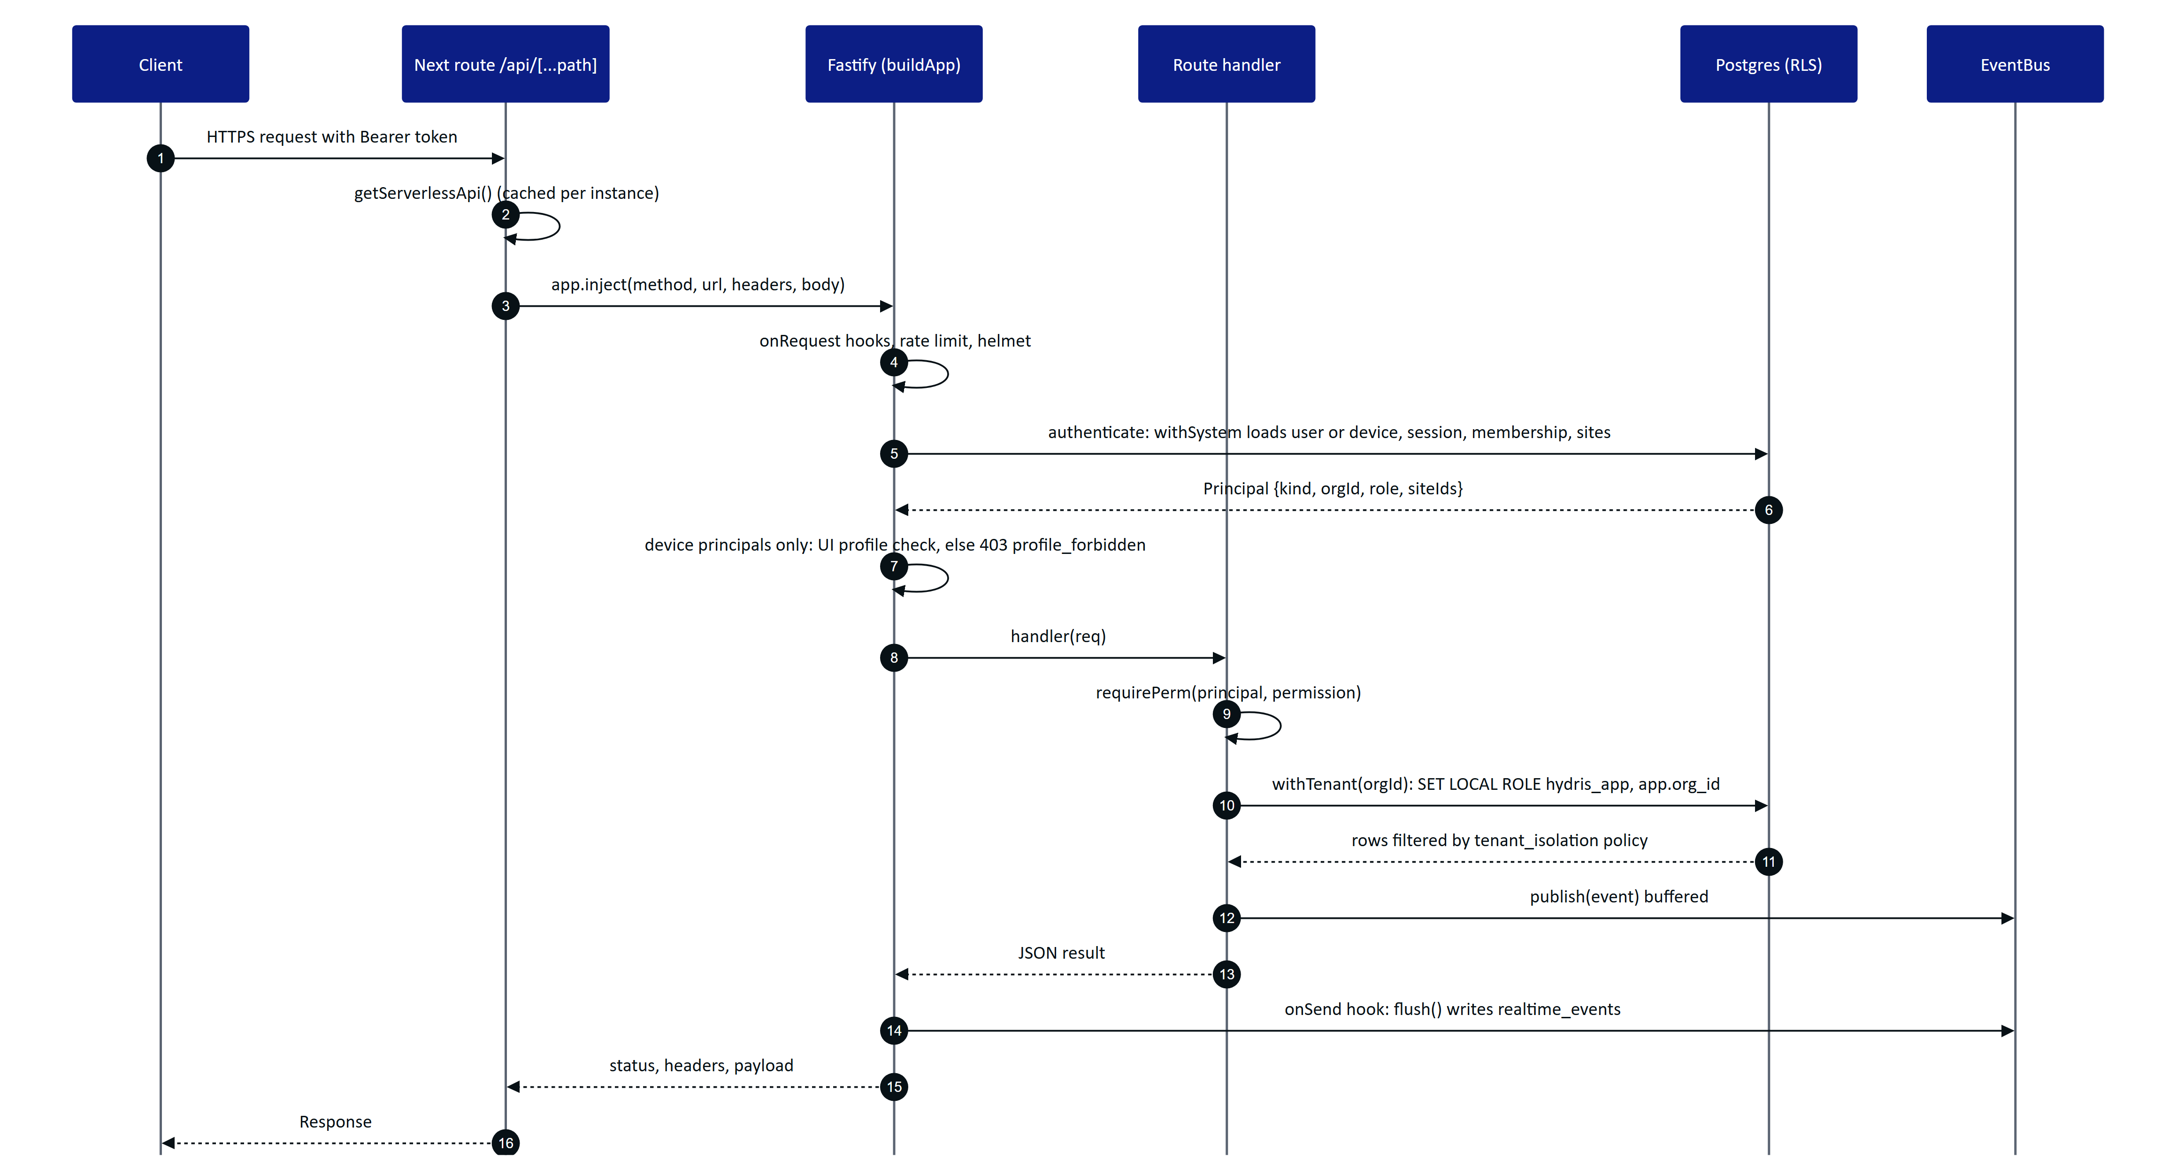
Figure 4. Request lifecycle for an authenticated call in the built-in API mode, from the Next.js route to the RLS-protected query and the event flush.
The order matters in three places:
- Principal resolution re-checks revocation on every request. resolveTokenPrincipal() loads the user status, confirms the session family in auth_sessions has not been revoked, and reloads the membership and site list. A device token is rejected if the device is not active, its session_version changed, or it has no current assignment. Logout and revocation therefore take effect on the next request, not when the 15 minute access token expires.
- The UI profile hook runs after authentication. installProfileEnforcement() is registered before the modules so that its onRoute hook can append a check to the matching routes. It only applies to device principals: a pair of glasses whose profile hides the alarms screen gets 403 profile_forbidden from GET /api/alarms even if the operator's role allows it.
- Events are written after the handler returns. In db realtime mode the bus buffers publishes and the onSend hook calls flush(), so event rows are inserted outside the handler's transaction (core/events.ts).

4.3 Error contract
All errors use one shape, produced by the error handler in app.ts and the helpers in core/errors.ts:
{ "error": { "code": "validation_failed", "message": "Some fields are invalid", "details": [{ "path": "readings.0.ts", "message": "Invalid ISO datetime" }] } }
Table 7. Error mapping
Source | Status | Code
HttpError thrown by a handler | As thrown (400, 401, 403, 404, 409) | As thrown, for example note_required, invalid_transition, stale
ZodError from request parsing | 400 | validation_failed, with details[] per field
Rate limiter | 429 | rate_limited
Anything else | 500 | internal_error, message masked as "Unexpected server error", stack logged
API failed to start (route handler) | 503 | service_unavailable with a short detail
SSE route in the wrong realtime mode | 503 | realtime_misconfigured

Records outside the caller's site scope return 404, not 403 (requireSite() in core/principal.ts), so a user cannot probe for the existence of another site's assets or alarms.

5 Domain model

5.1 Key domain types
packages/domain is the vocabulary of the system. It has no I/O and is imported by the API, the web app and (by convention, mirrored by hand) the Android app.
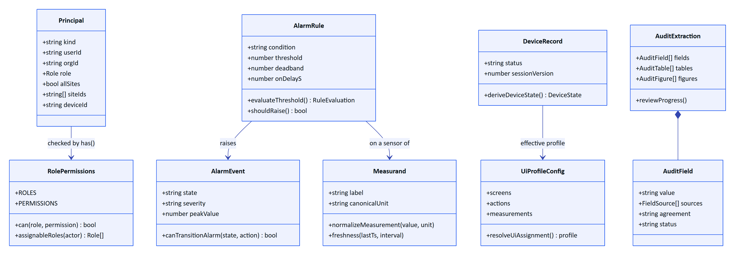
Figure 5. Key domain types and the functions that own their rules (packages/domain/src and apps/api/src/core/principal.ts).
Table 8. Domain modules
File | Owns | Used by
roles.ts | 6 roles, the permission list, ROLE_PERMISSIONS, assignableRoles, SITE_SCOPED_BY_DEFAULT | API authorisation, console navigation, Android visibility
measurands.ts | Measurand definitions (label, units, conversions, typical range, decimals), normalizeMeasurement | Ingestion, charts, voice answers
freshness.ts | live, delayed, stale, no_data from last timestamp and expected interval | Console, HUD, stale-data alarms
alarms.ts | Severities, conditions, states, ALARM_TRANSITIONS, evaluateThreshold (deadband), shouldRaise (on-delay) | Alarm engine, console, HUD
workflows.ts | Inspection and maintenance state machines, step kinds, progress | Inspections and maintenance modules
devices.ts | Device states, deriveDeviceState, pairing alphabet (30 characters), length 8, TTL 300 s, poll interval 3 s | Pairing, fleet views
uiprofile.ts | Screens, widgets, actions, text scales, precedence device then user then role then org | Profile enforcement, HUD
auditdoc.ts | OCR types, key/value and table structuring, cross-check, plausibility, agreement score | Audit scan pipeline on client and server
voice.ts | Wake phrase regex (WAKE_RE), utterance normalisation, measurand detection | Web voice, rules engine
scenarios.ts, random.ts, catalog.ts | Simulation scenarios with deterministic noise, enumerations | Simulator, seeds

5.2 Alarm state machine
Alarm transitions are data, not code paths: ALARM_TRANSITIONS in packages/domain/src/alarms.ts lists for each action the allowed source states, the target state, the permission and whether a note is required. transitionAlarm() in modules/alarms.ts applies it, writes alarm_event_history, appends an audit event and publishes alarm.updated. The transitions are: acknowledge (active to acknowledged), investigate (active or acknowledged to investigating), resolve (acknowledged or investigating to resolved, note required) and close (resolved to closed). The condition clearing (clearedAt) is separate from the human workflow: an alarm whose value returned to normal stays open until someone acknowledges and resolves it.

6 Data architecture and tenancy

6.1 Schema overview
apps/api/src/db/schema.ts defines 42 tables. DATA_MODEL.md documents each column; this chapter covers the structural decisions.
Table 9. Table groups
Group | Tables | Notes
Identity and tenancy | users, organizations, memberships, membership_sites, invitations, auth_sessions, auth_tokens, mail_outbox | users is global; membership is per organization
Plant model | sites, facilities, process_areas, assets, gateways, sensors, documents, attachments | Hierarchy site, facility, process area, asset, sensor
Telemetry and alarms | telemetry_readings, telemetry_corrections, alarm_rules, alarm_events, alarm_event_history | Readings are immutable; corrections supersede for display
Work | inspection_templates, inspection_routes, inspections, inspection_responses, maintenance_tasks, maintenance_activity | inspections.revision for optimistic concurrency
Devices | devices, device_assignments, pairing_challenges, device_sessions | Assignment history is kept (unassigned_at)
Glasses UI | ui_profiles, ui_profile_versions, ui_profile_assignments | Versioned configuration
Audit documents | audit_documents, audit_document_pages, audit_document_events | Page images stored in the database as base64 text
Platform | notifications, audit_events, inquiries, simulation_runs, realtime_events | realtime_events is system-only

telemetry_readings uses a bigint identity key, a unique index on (sensor_id, ts) that makes ingestion idempotent, a descending (sensor_id, ts) index for latest-value and history reads, and an (org_id, ts) index. There is no partitioning or retention policy yet.

6.2 Row-level security
Tenant isolation is enforced by Postgres, not only by application code.
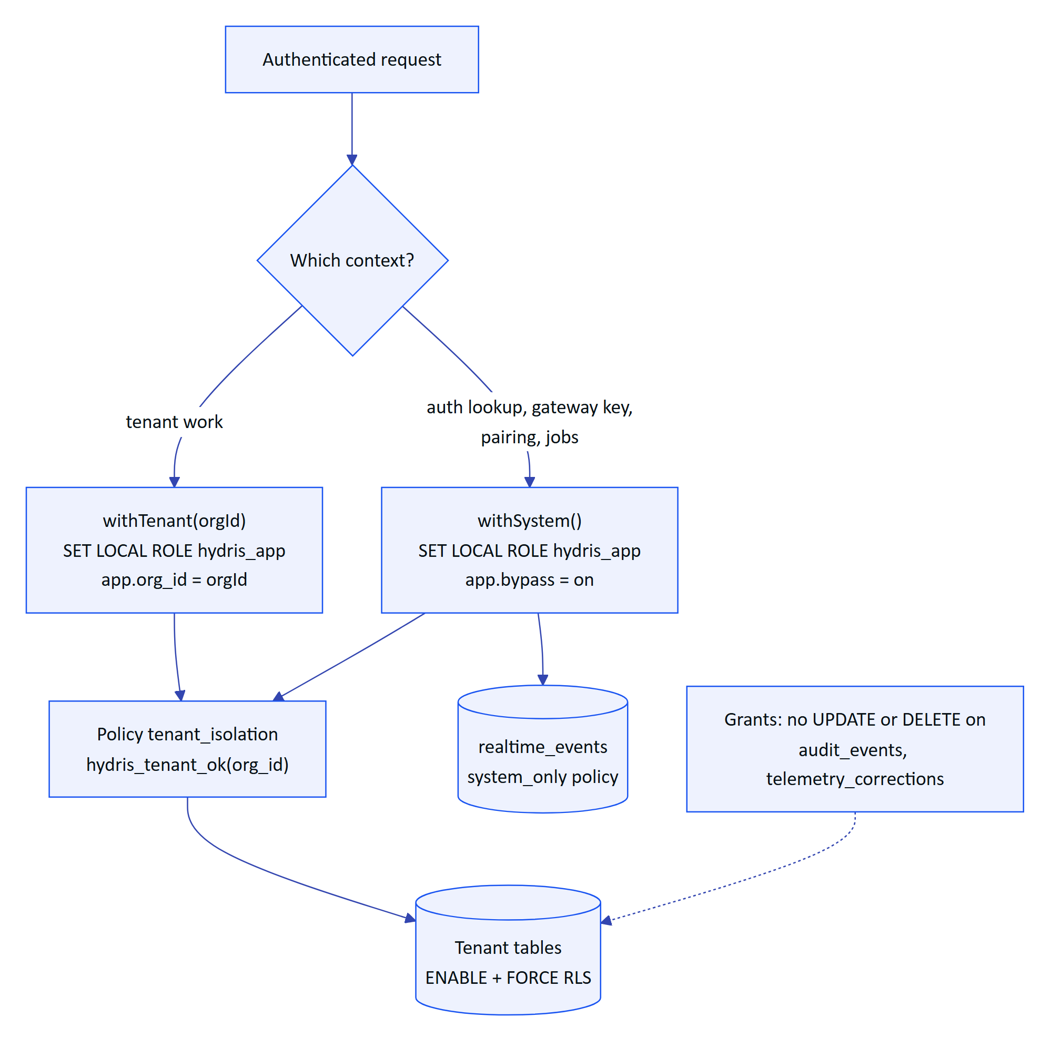
Figure 6. How a request reaches tenant rows. Both contexts run as the non-privileged hydris_app role; only the session settings differ.
The mechanics, from drizzle/0001_rls.sql, 0003, 0006, 0008 and db/tenant.ts:
- hydris_app is created NOLOGIN and without BYPASSRLS. Migration 0004_app_role_membership.sql grants the connecting owner role membership WITH SET TRUE so that managed Postgres (PG16+) allows SET ROLE.
- hydris_tenant_ok(row_org) returns true when app.bypass is on or when row_org equals app.org_id. Every tenant table has a tenant_isolation policy USING and WITH CHECK that function, so both reads and writes are checked.
- withTenant() and withSystem() each open a transaction and use SET LOCAL and set_config(..., true), so settings cannot leak to the next request on a pooled connection.
- audit_events and telemetry_corrections have UPDATE and DELETE revoked from hydris_app, and audit_document_events has only SELECT and INSERT. Even system context cannot rewrite history.
- realtime_events uses a system_only policy: clients never read it directly; the stream reads it in system context and filters per connection.
DECISION
Postgres RLS as the last line of tenant isolation. The application already filters by organization and site. RLS makes a forgotten WHERE clause a non-event instead of a data breach, and it lets a security reviewer verify isolation by reading 46 lines of SQL instead of every query. The cost is that every request runs in a transaction, and system work must be explicit (withSystem), which is a useful signal in code review.

6.3 Append-only records and provenance
- A manual or lab reading is stored as an ordinary immutable reading; the audit row (telemetry.manual_entry) is the provenance record of who entered it (modules/telemetry.ts).
- Corrections never overwrite telemetry_readings. A telemetry_corrections row supersedes the value for display and aggregation, and history queries compute effective values with a lateral join.
- Audit document reviews keep the first extracted value in extracted and write every confirm, correct, flag, verify and approve action to audit_document_events.
- Synthetic data is marked (synthetic = true) and ingest() refuses simulator data for any tenant that is not a demo organization (synthetic_not_allowed).

6.4 Migrations
Nine SQL migrations (apps/api/drizzle/0000_init.sql to 0008_audit_documents_rls.sql) are generated by drizzle-kit and applied by the Drizzle migrator. On Postgres, createDatabase().migrate() takes a session-level advisory lock (key 4872917633) on a dedicated connection, so several serverless instances cold-starting at once, or a deploy and an instance, cannot run migrations concurrently (db/client.ts). On Vercel the migrations folder is shipped with the functions through outputFileTracingIncludes in apps/web/next.config.ts and located at runtime by findMigrationsFolder().

7 Identity, sessions and tokens

7.1 Token model
Table 10. Credentials
Credential | Format and lifetime | Held by | Revocation
User access token | JWT HS256 {typ: user, sub, org, sid}, 15 min (12 h in demo mode) | Client memory only | sid is the refresh family; revoking the family invalidates access tokens on the next request
User refresh token | 48 random bytes, SHA-256 stored in auth_sessions, 7 days, cookie hg_refresh (httpOnly, SameSite=Strict, path /api/auth, Secure in production) | Browser cookie jar; Android encrypted cookie store | Rotation on every use; replay after 30 s revokes the family
MFA challenge | JWT {typ: mfa}, 5 min | Client | Single step
Device access token | JWT {typ: device, sub, org, sv}, 15 min | Device memory | devices.session_version bump, suspend, revoke, unassign
Device refresh token | hgd_ plus 40 random bytes, device_sessions, 30 days, rotating | Android Keystore-encrypted store; web localStorage | Reuse revokes the family and is audited (device.refresh_reuse_detected)
Gateway key | hgw_ prefix, SHA-256 in gateways.key_hash | Gateway | POST /api/gateways/:id/revoke
Demo session cookie | Signed JWT hg_demo | Browser | Demo mode only
Demo device refresh | hgd_z plus HMAC-signed claims (org, device, user, site, version) | Device | Demo mode only

Passwords are hashed with argon2id (memory 19456 KiB, time cost 2, parallelism 1) and a dummy verification burns equal time for unknown emails (core/crypto.ts). TOTP secrets are encrypted at rest with AES-256-GCM under DATA_KEY.

7.2 Refresh rotation and reuse detection
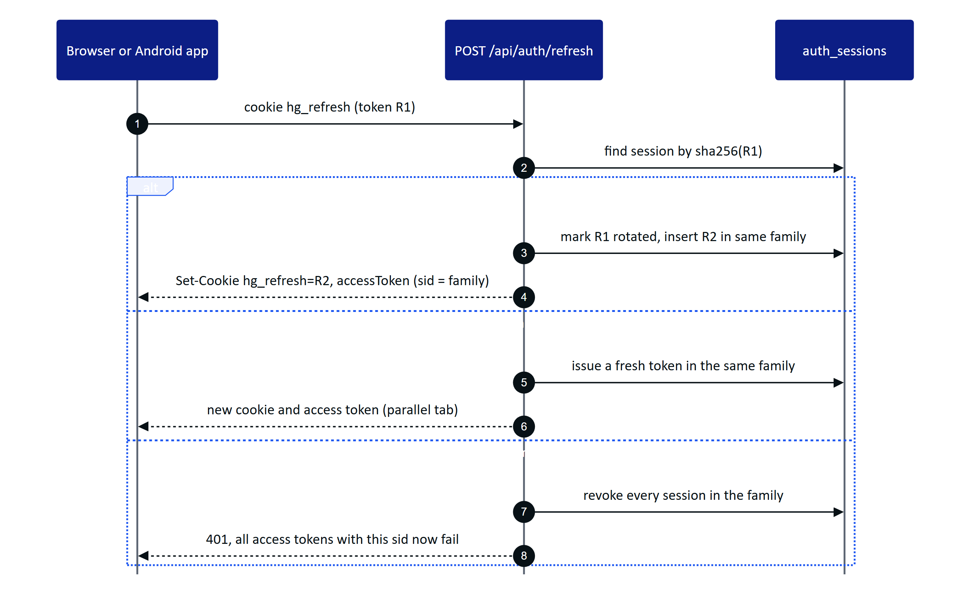
Figure 7. User refresh rotation with family revocation (modules/auth.ts). The 30 s grace absorbs parallel tabs; a later replay is treated as theft.
Clients refresh with a single-flight guard so parallel 401s trigger one refresh: refreshSession() in apps/web/src/lib/api.ts, refresh() in apps/web/src/glasses/link.ts, and a coroutine Mutex in HydrisApi.kt on Android.

7.3 Session and token states
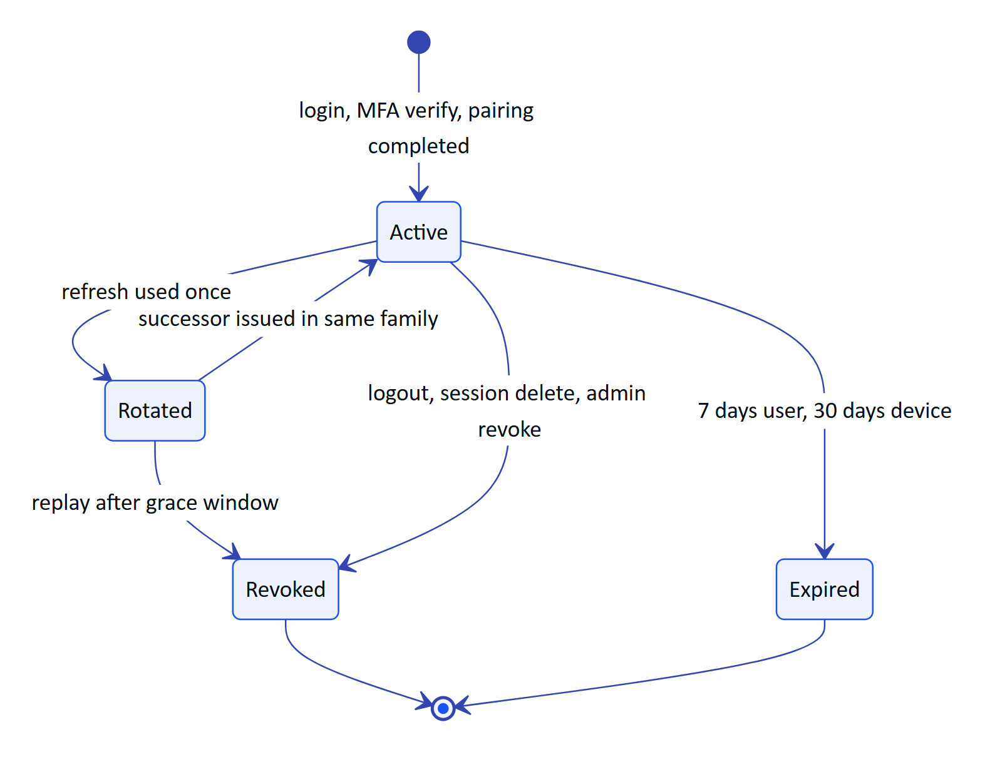
Figure 8. Lifecycle of a refresh-token family (user sessions in auth_sessions, device sessions in device_sessions).

7.4 Principals and permissions
A verified token becomes a Principal (core/principal.ts). Devices act on behalf of their assigned operator: a device principal carries the operator's userId, role and sites, and has() additionally requires the permission to be in DEVICE_PERMISSIONS, a fixed set of 13 permissions (read site, asset, telemetry, alarm, inspection, maintenance, document and audit document data; acknowledge alarms; execute inspections and maintenance; request maintenance; capture audit documents). Glasses therefore can never verify or approve a document, manage members or edit rules, whatever the operator's role. Audit document verification and approval add an explicit p.kind !== 'user' check on top.

8 Devices and pairing

8.1 Pairing flow
Pairing follows the shape of the OAuth 2.0 Device Authorization Grant (RFC 8628). The glasses or the app requests a challenge, shows a short code and a QR link, and a signed-in person approves it. The QR encodes only the verification URL and the short code, never a credential.
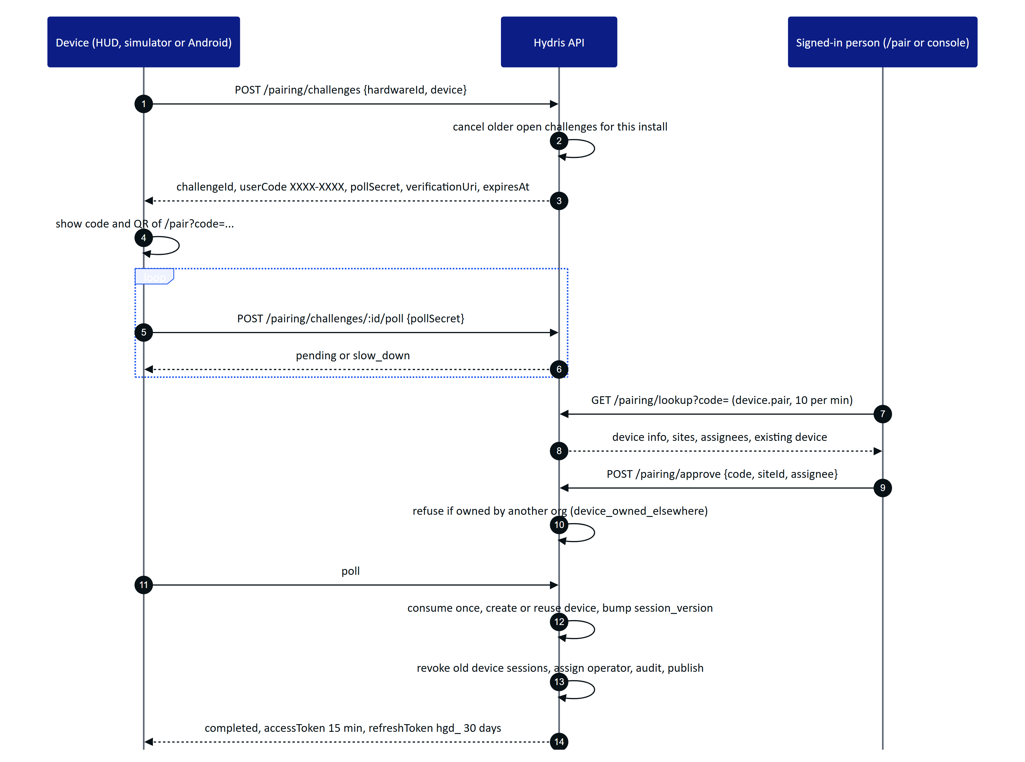
Figure 9. Device pairing (modules/devices.ts). The poll secret is never displayed; the code is single use and expires after 300 s.
The Android app uses the same endpoints but approves its own challenge with the signed-in user's session: Repository.registerGlasses() creates the challenge with the DAT hardware id, looks the code up, approves it for the first site the user can see, and polls for the tokens. The web HUD, the simulator and the companion bridge use the two-device flow shown above.
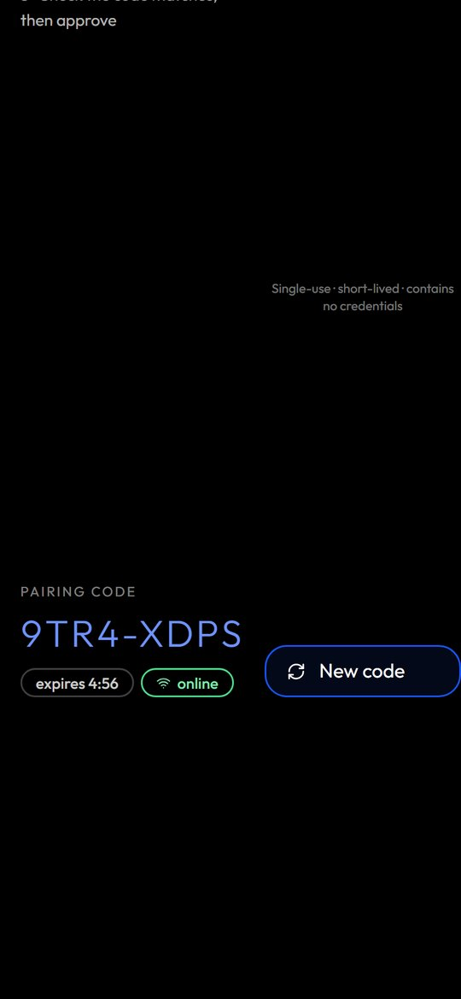
Figure 10. The pairing page on a phone: the operator enters or scans the short code and picks the site and assignee.

8.2 Device lifecycle
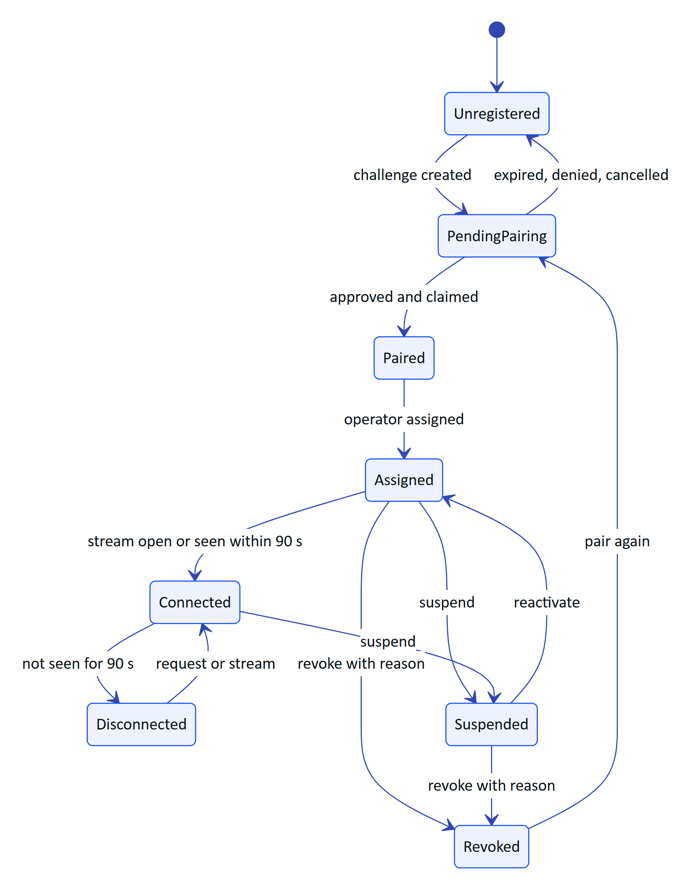
Figure 11. Device lifecycle as shown to administrators (deriveDeviceState in packages/domain/src/devices.ts). Online means an open stream or seen within 90 s.
Suspension and revocation bump nothing in the token itself; they change devices.status, which resolveTokenPrincipal() reads on every request. Revocation also revokes all device_sessions, closes the assignment and publishes device.revoked to that device only.

8.3 Glasses UI profiles
Administrators decide what each role or device sees on glasses without shipping an app. A profile (ui_profiles, versioned in ui_profile_versions) lists enabled screens, widgets, allowed actions, measurand filters and text scale. Assignments resolve with the precedence device, then user, then role, then organization (UI_SCOPE_PRECEDENCE in packages/domain/src/uiprofile.ts). The API enforces the effective profile on device requests through the route rule table in modules/ui-profiles.ts and caches each device's effective profile for 5 s. A change invalidates the cache and publishes device.profile_changed to the affected devices, which reload their context.

9 Telemetry and alarms

9.1 Ingestion and alarm raising
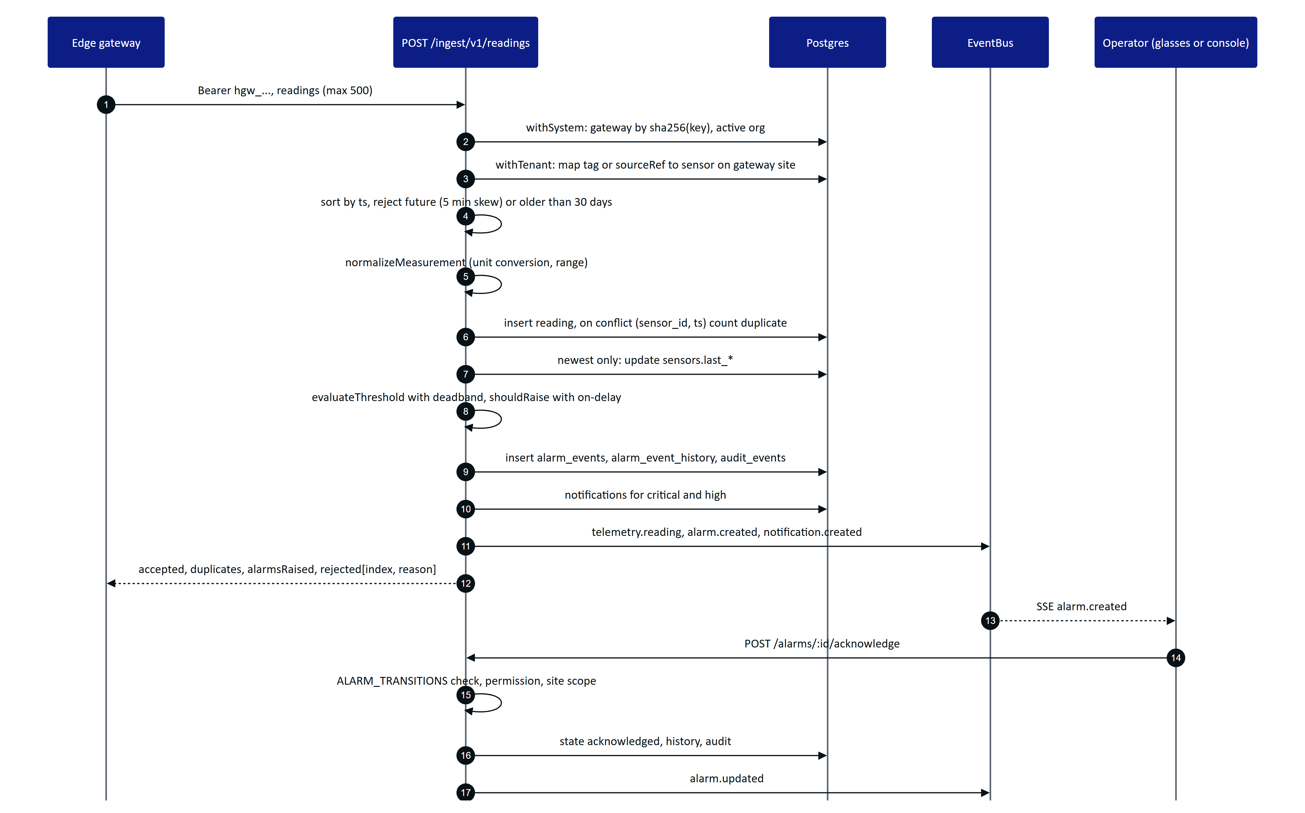
Figure 12. Telemetry ingestion, alarm raising and acknowledgement. Every source shares ingest() in modules/telemetry.ts.
Design points worth knowing:
- Out-of-order data is stored for history but does not overwrite a newer latest value or re-trigger alarm evaluation.
- Hysteresis: once in alarm, a value inside the deadband reports holding, not normal, so a noisy signal does not flap. A breach must persist for onDelayS (tracked in alarm_rules.breach_since) before an alarm is raised.
- One open event per rule: a continuing breach only updates peak_value. When the value returns to normal the event gets cleared_at but stays open for people to acknowledge and resolve.
- Bad quality readings update the latest value but skip alarm evaluation.
- Partial success: the gateway receives per-reading rejections with the original index, so it can retry or drop individual readings.

9.2 Stale-data alarms and background jobs
"No fresh data" rules cannot be evaluated on ingestion, because the problem is the absence of readings. evaluateStaleRules() scans all enabled stale rules across tenants in system context. jobs.ts schedules it and three other jobs.
Table 11. Background jobs
Job | Long-running server (startJobs) | Vercel (/api/cron via runScheduledJobs) | Demo mode
Stale-data rules | Every 30 s | Once per cron run: vercel.json schedules 0 3 * * * (daily) | Not ticked by DemoTicker
Pairing expiry | Every 60 s | Once per cron run | Challenges also expire by expiresAt checks
Realtime event pruning (older than 1 day) | Hourly in db mode | Once per cron run | Per instance memory
Simulation steps | setInterval per run, 5 s | Once per cron run | DemoTicker.poke() on API activity, at most every 5 s

WARNING
In the all-Vercel topology the cron runs once a day, so stale-data alarms are raised at most daily. A production plant on Vercel needs a more frequent scheduler (a higher cron tier or an external trigger calling /api/cron with CRON_SECRET) or the API in a container where startJobs runs every 30 s. This is tracked as TD-02.

10 Realtime

10.1 Server-Sent Events
Clients receive domain events over Server-Sent Events. The connection is made with fetch(), not the browser EventSource, so the bearer token travels in the Authorization header and never in a URL (apps/web/src/lib/realtime.ts). The Android app does the same with OkHttp (HydrisApi.events()).
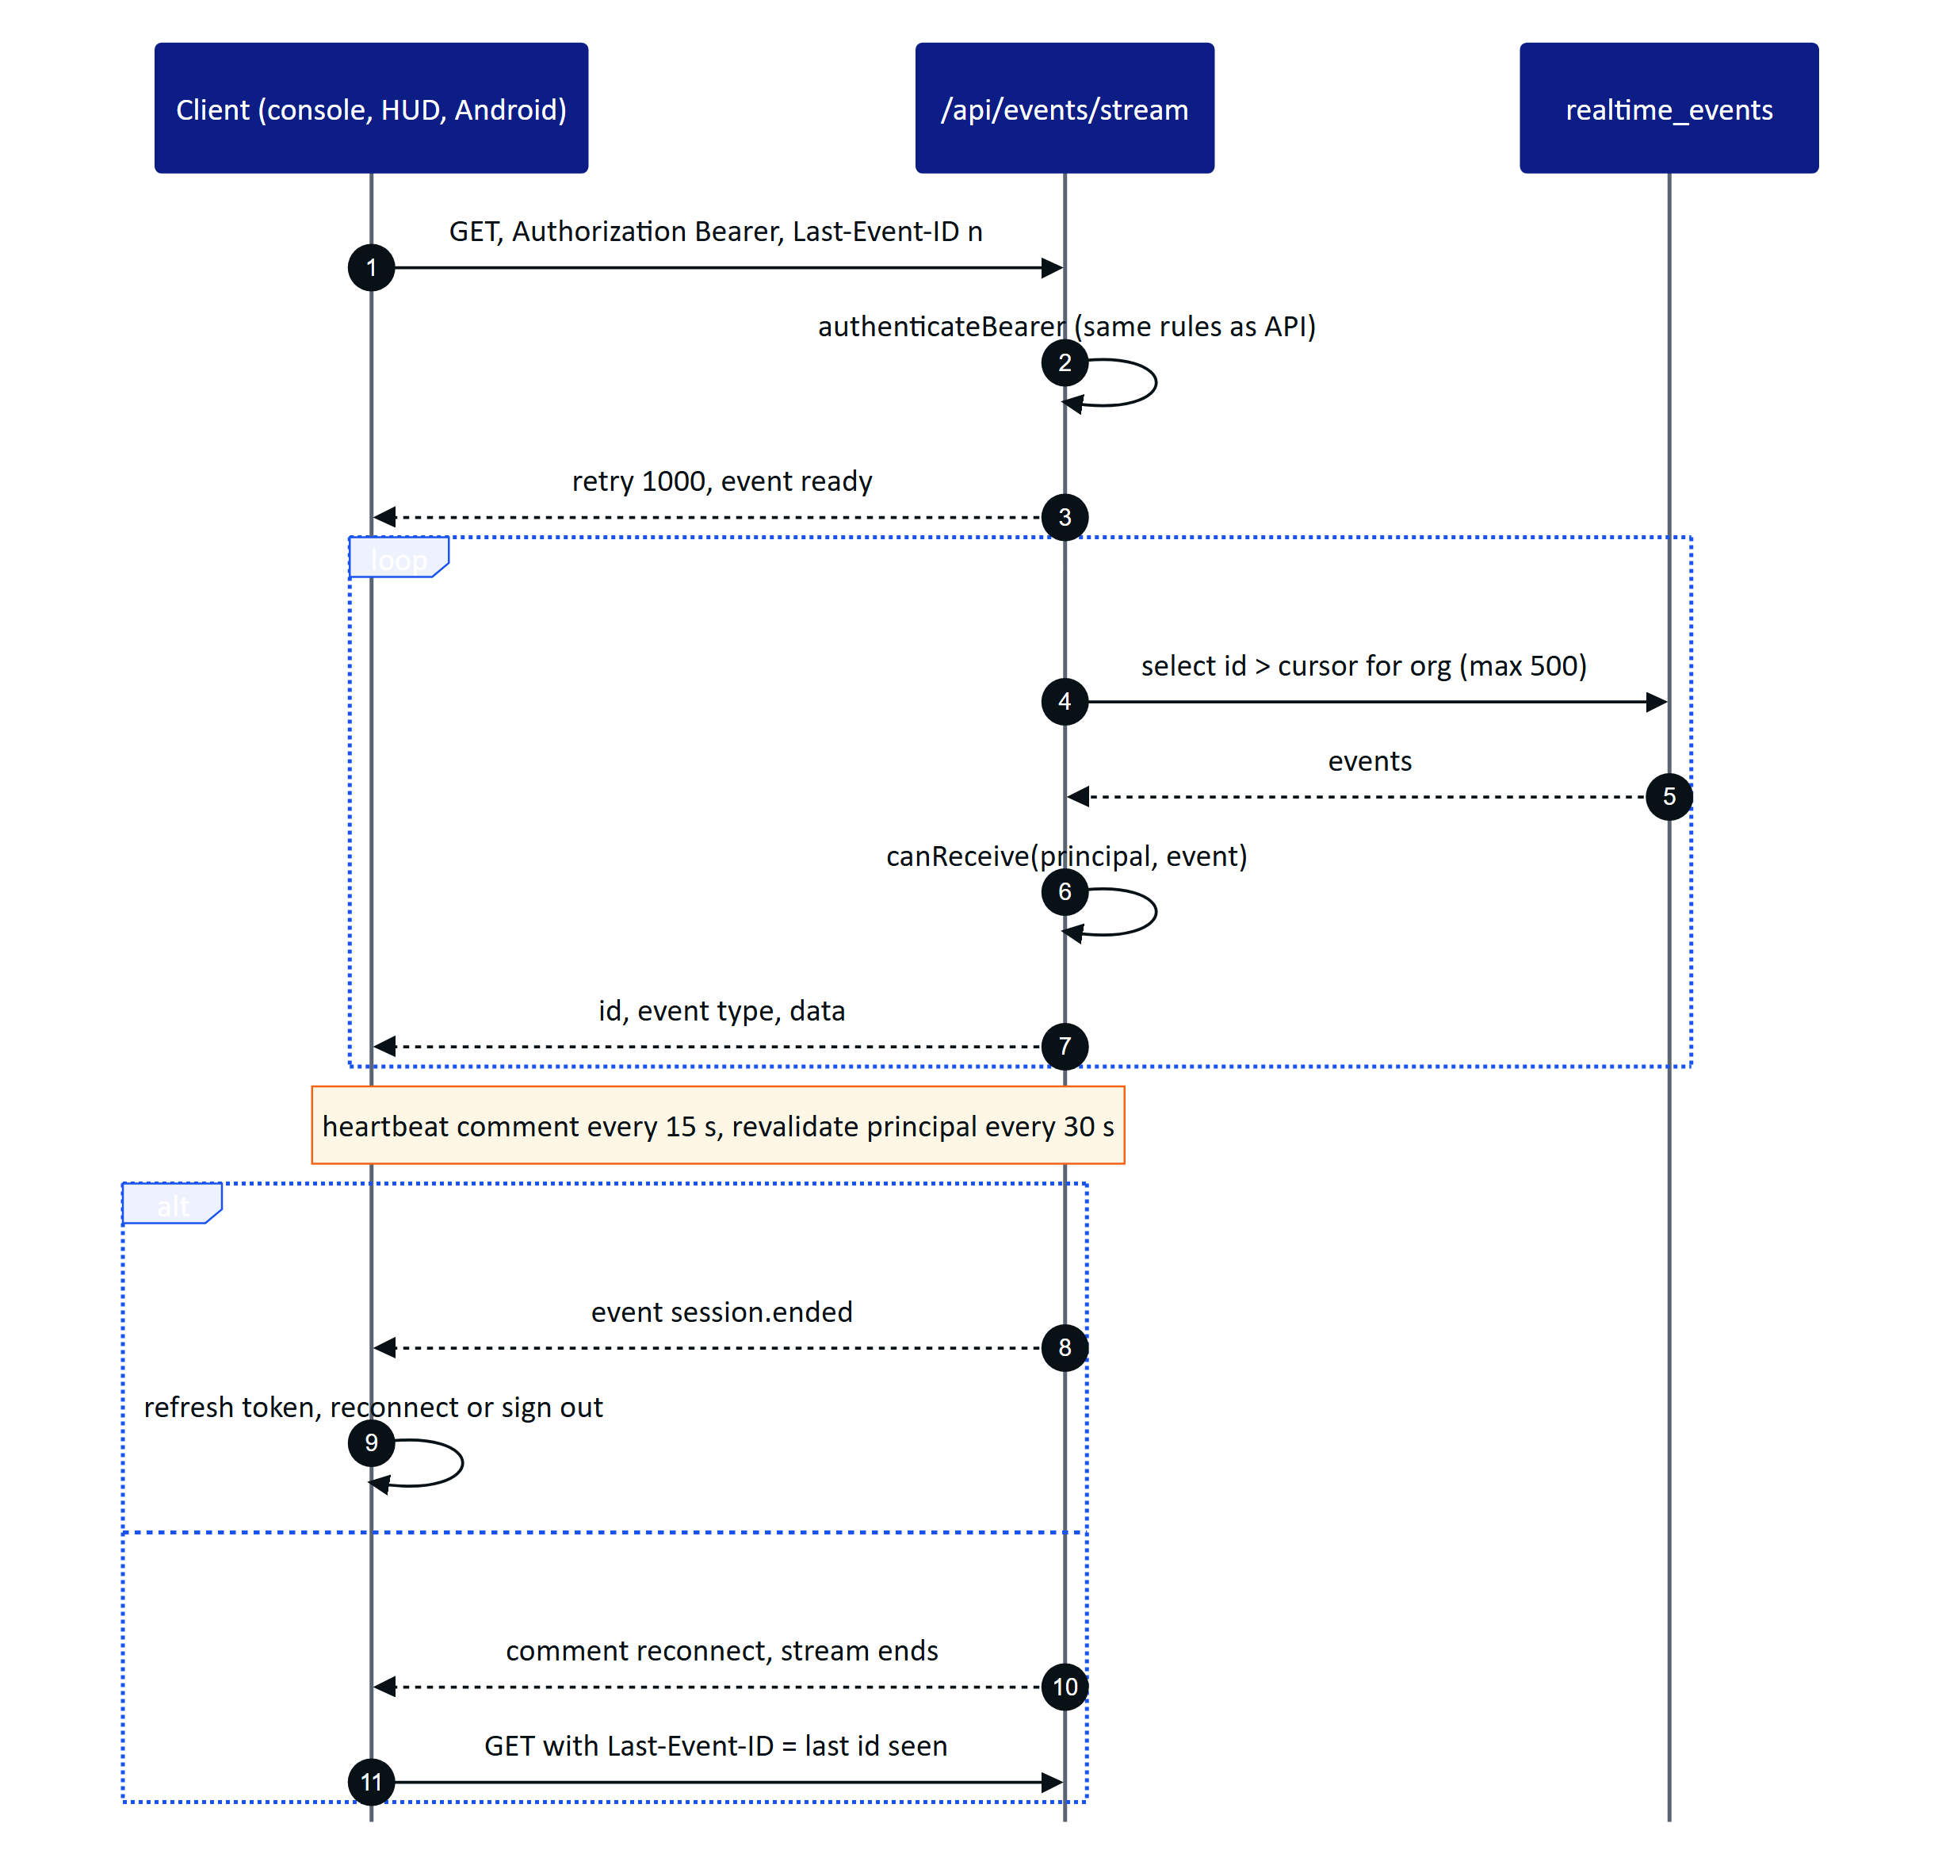
Figure 13. SSE in db mode on Vercel. Each invocation streams for about 50 s, then the client reconnects with Last-Event-ID and resumes without gaps.
Table 12. Realtime modes (REALTIME_MODE, core/events.ts)
Aspect | memory | db
Transport inside the API | In-process EventEmitter | Buffered rows in realtime_events, flushed in onSend
Fan-out across instances | No (single instance) | Yes, every instance polls the same table
Replay on reconnect | Ring buffer of the last 1,000 events | Any event id still in the table (pruned after 1 day)
Latency | Immediate | Up to the 1.5 s poll interval
Device presence | ctx.liveDevices counts open streams | devices.last_seen_at
Used by | server.ts default, Docker Compose, Render | Vercel, demo mode, any multi-instance deployment

Authorisation is per connection and per event (canReceive in modules/realtime.ts): the event's organization must match, device-targeted events go only to those devices, user-targeted events only to those users, and site and permission constraints apply. Events carry identifiers and small payloads; clients refetch through the normal API, which applies RLS again.
The console batches invalidations: Shell.tsx maps event types to API path prefixes (EVENT_PATHS) and invalidates matching TanStack Query entries every 1.5 s, while critical and high alarm.created events raise a toast immediately.
Table 13. Event types published today
Area | Events
Telemetry and alarms | telemetry.reading, telemetry.corrected, sensor.updated, alarm.created, alarm.updated
Work | inspection.updated, maintenance.updated, notification.created
Plant | asset.updated, simulation.step
Devices | pairing.completed, device.paired, device.updated, device.context_changed, device.profile_changed, device.revoked
Documents and UI | auditdoc.updated, ui_profile.updated

DECISION
SSE instead of WebSockets. All realtime traffic is server to client; client actions are ordinary authenticated HTTP calls that go through the same validation, RBAC and RLS. SSE works through the Vercel function model (a streamed response with a time budget), through corporate proxies, and with plain fetch on every client. WebSockets would need a separate stateful service on Vercel. The price is polling in db mode and a reconnect every 50 s, both acceptable at pilot scale.

11 Audit document scanning

11.1 Pipeline
Paper logbooks, lab sheets and permits become verified digital records through a pipeline that combines on-device OCR, server structuring, an optional vision model and two human steps.
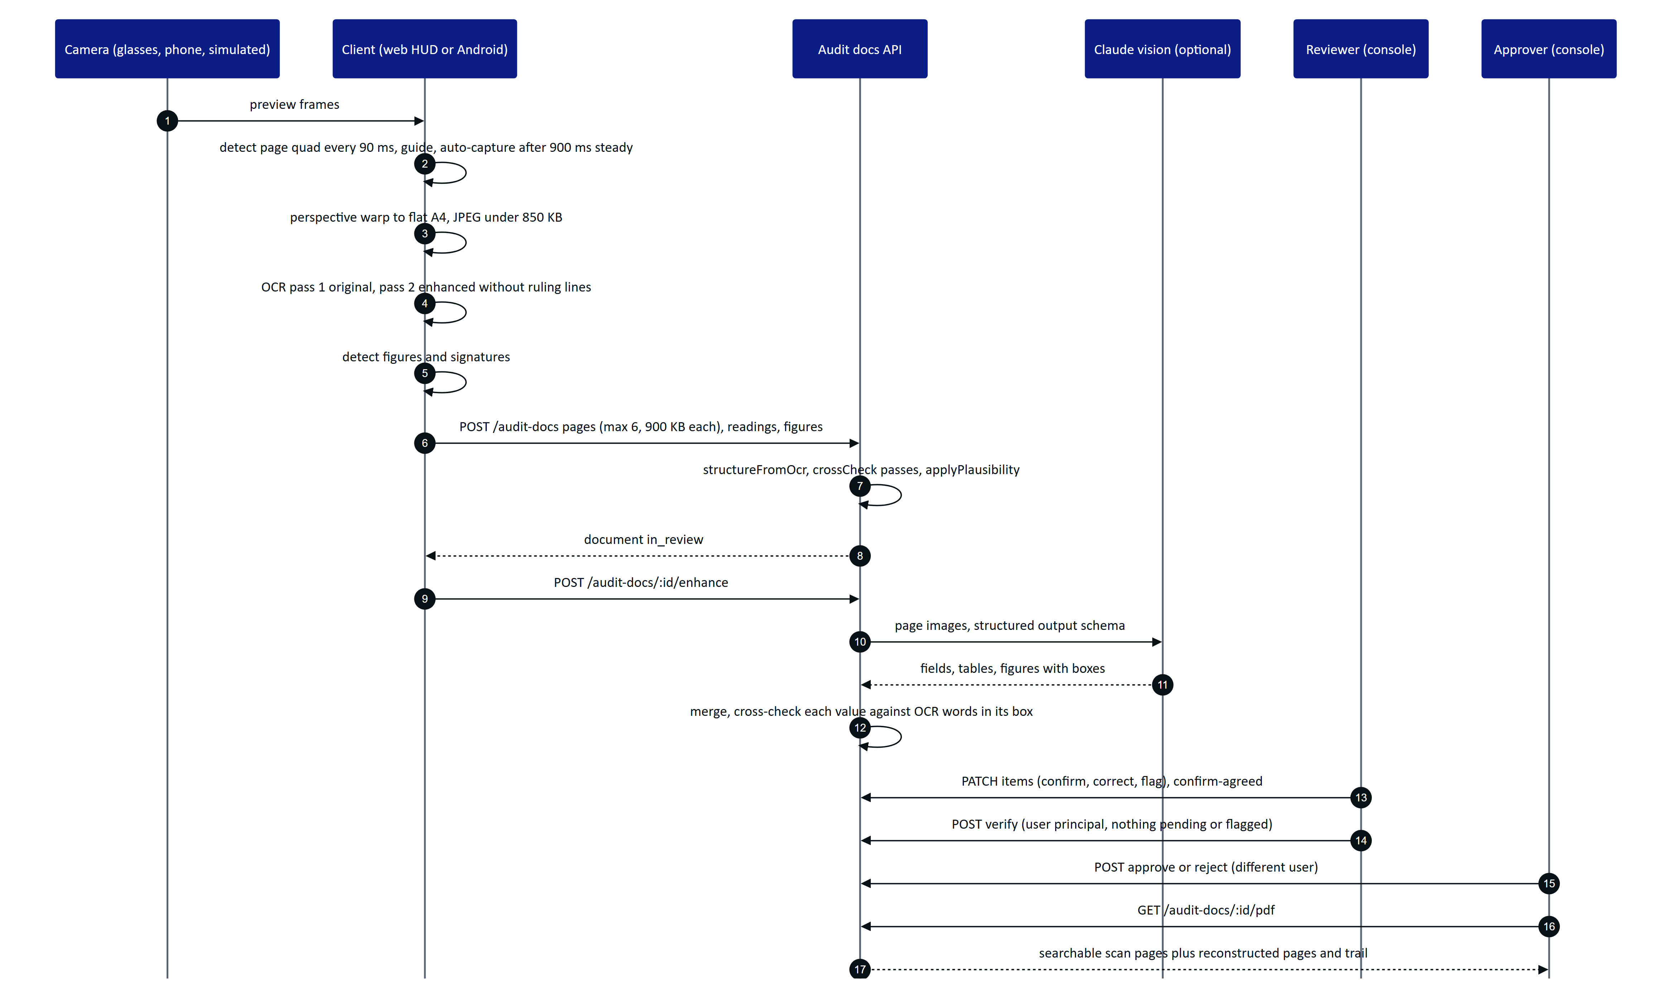
Figure 14. Audit scan pipeline from camera to approved PDF (lib/docdetect.ts, lib/ocr.ts, modules/audit-docs.ts, core/vision-extract.ts, core/audit-pdf.ts).
Key properties:
- Two independent machine readings. Each page is read twice on the device, once as captured (ocr:original) and once contrast-normalised with ruling lines removed (ocr:enhanced). The web uses Tesseract.js in WebAssembly (apps/web/src/lib/ocr.ts); Android uses ML Kit (scan/OcrEngine.kt) and emits exactly the same JSON shape. Disagreement between passes is a signal for the reviewer, which is why the server stores per-field sources and an agreement value (match, close, mismatch, single).
- No image leaves the device before upload. Detection, warping and OCR run locally. The web warp produces a 1654 px wide A4 page (warpToA4 default; the file header comment still says 1240 by 1754).
- Vision is additive. If no Anthropic credential is configured, enhance returns aiStatus: unavailable and the OCR result stands. If the model fails, aiStatus becomes failed with a short reason and the OCR result stands. Vision cannot replace an extraction once review has started (409 review_started).
- Dual human verification. Verification and approval require a user principal signed in to the console, and approval must come from a different person than the verifier. Demo tenants may self-approve, and the event records it as such.
- Optimistic concurrency. Every write is UPDATE ... WHERE revision = n; a lost race returns 409 stale and the client reloads.

11.2 Document states
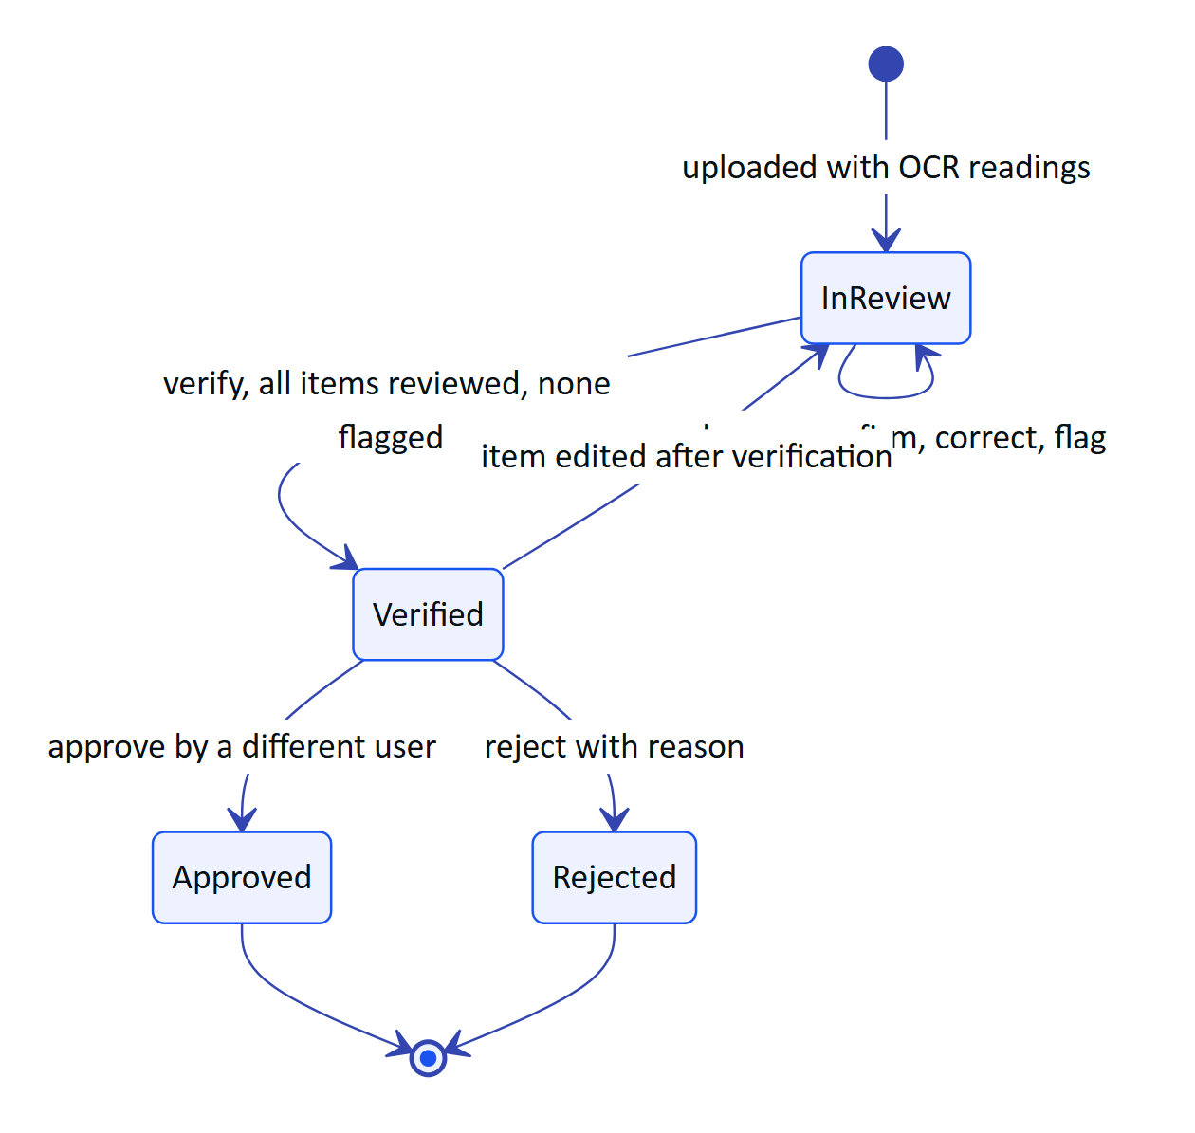
Figure 15. Audit document states (AuditDocStatus in packages/domain/src/auditdoc.ts). Editing a verified item reopens review.
The schema also defines a processing status for server-side processing; the current upload path writes in_review directly because structuring is synchronous.
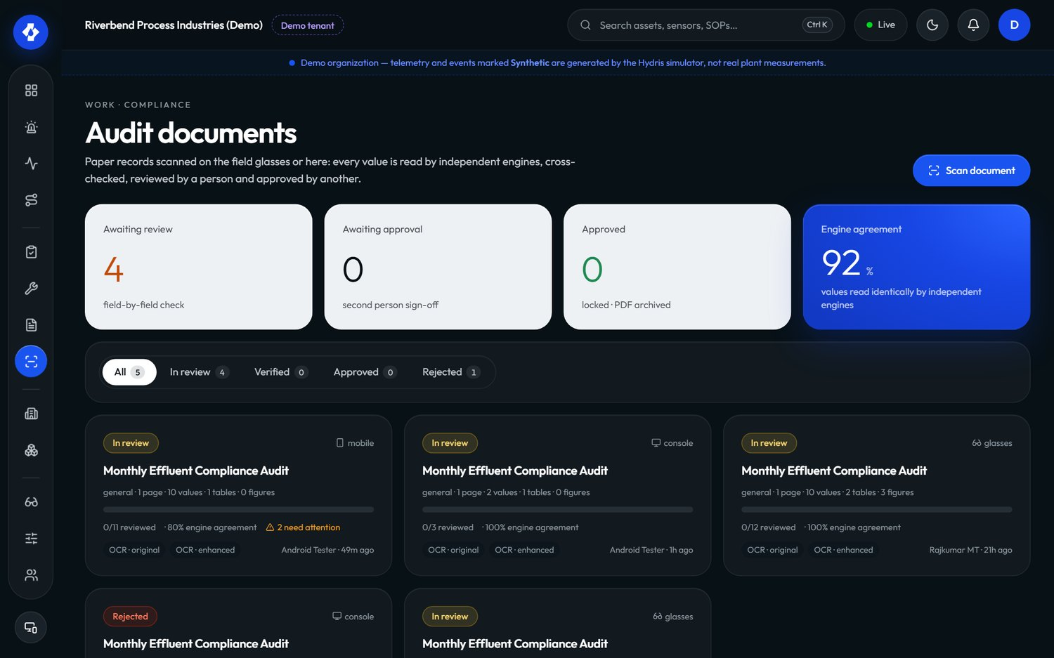
Figure 16. Audit documents in the console: agreement score, items needing attention and review progress per scan.

12 Voice assistant
"Hey Hydris" answers spoken questions with data from the caller's own account. The wake phrase is matched on the client (WAKE_RE in packages/domain/src/voice.ts, which tolerates common mis-transcriptions such as "hydras" or "idris"), and the question after the wake phrase goes to POST /api/assistant/ask.
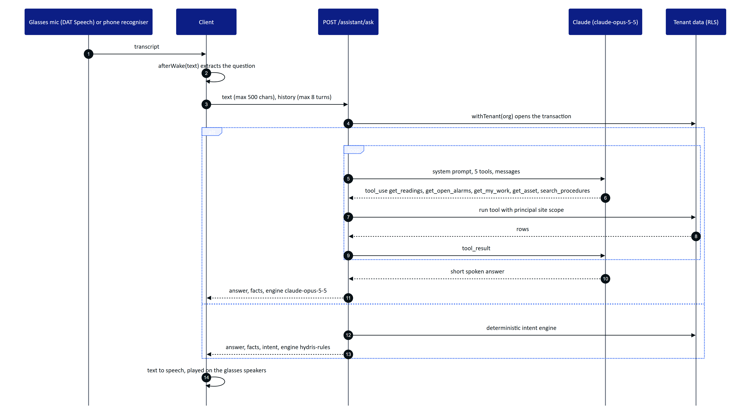
Figure 17. Voice assistant with tool use (modules/voice-assistant.ts). Tools run inside the caller's tenant transaction, so RLS and site scope apply to every lookup.
The system prompt forbids estimating or inventing values, asks for the age of each reading, and states that Hydris never operates equipment. The rules engine never guesses: an unrecognised question gets a plain "I can't answer that". The response's facts[] list the readings used (label, value, unit, time, and whether they are synthetic), so the client can show what an answer was based on. The endpoint is rate limited to 60 calls per minute.
DECISION
Grounded tool use with a deterministic fallback. The model never sees the database; it can only call five read-only tools that execute inside the caller's tenant transaction. The deterministic engine keeps the feature working (with narrower coverage) when no credential is configured, the provider is unavailable, or a customer forbids external AI processing.

13 Client applications

13.1 Web application
One Next.js application serves four very different experiences from one deployment.
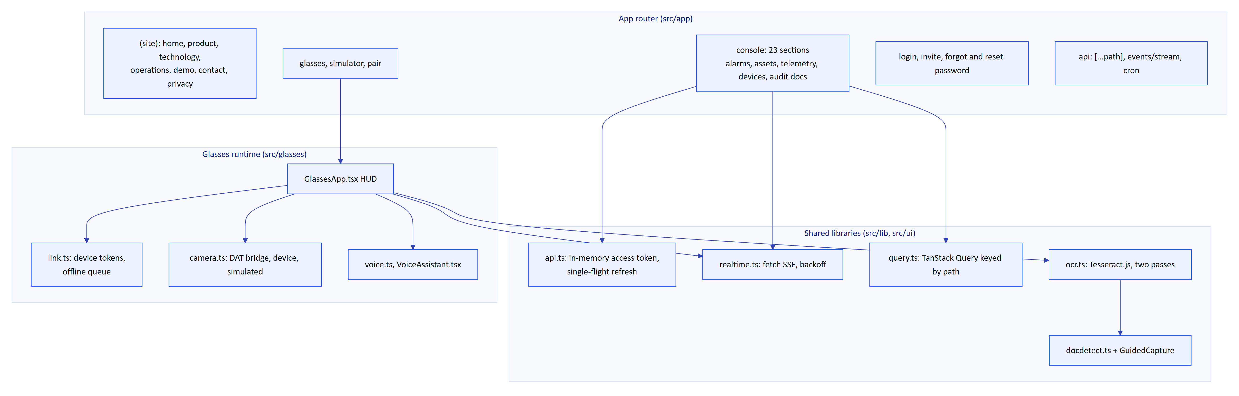
Figure 18. Web application components (apps/web/src). The glasses HUD and the console share the API client and realtime client but not their session model.
- Console sessions keep the access token in memory and the refresh token in the httpOnly cookie. Data is fetched with TanStack Query, where the API path is the cache key so that realtime events can invalidate by prefix (lib/query.ts).
- Glasses HUD sessions are device sessions. link.ts stores the install id and device refresh token behind a SecureStore interface (web implementation: localStorage), and keeps an offline queue of inspection step responses. Each queued operation carries a client id, and the server deduplicates on (inspection_id, client_op_id), so replays after a network drop are safe.
- Simulator (/simulator) renders the 600 by 600 additive HUD (GLASSES_DISPLAY in packages/domain/src/devices.ts) in a browser, with a simulated camera that films a sample A4 sheet so the whole scan pipeline can be demonstrated without hardware.
- Security headers come from next.config.ts: X-Frame-Options: DENY everywhere except /glasses and /simulator (SAMEORIGIN, so the website can embed the live demo), nosniff, a strict referrer policy and a permissions policy that allows only the camera for the same origin. Helmet runs in the API with its content security policy disabled.
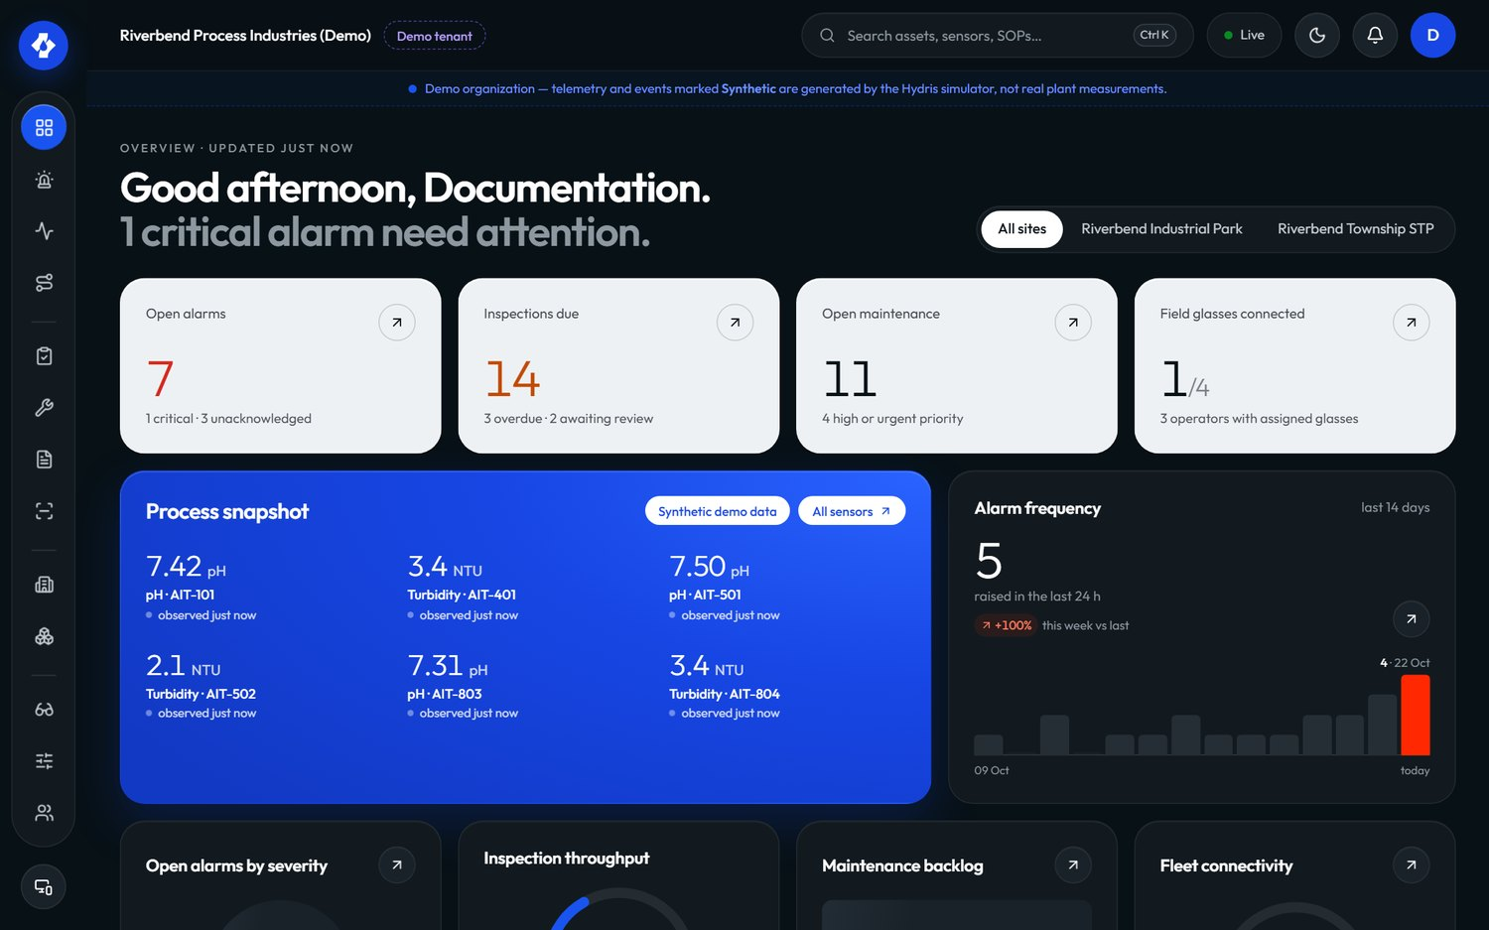
Figure 19. Operator console overview: KPIs, open alarms by severity and live instruments for the selected site.

13.2 Android app: Hydris Field
Hydris Field (apps/android, package ai.hydris.field, minSdk 31 to match DAT, targetSdk 36) is the operator's phone app and the bridge to the glasses.
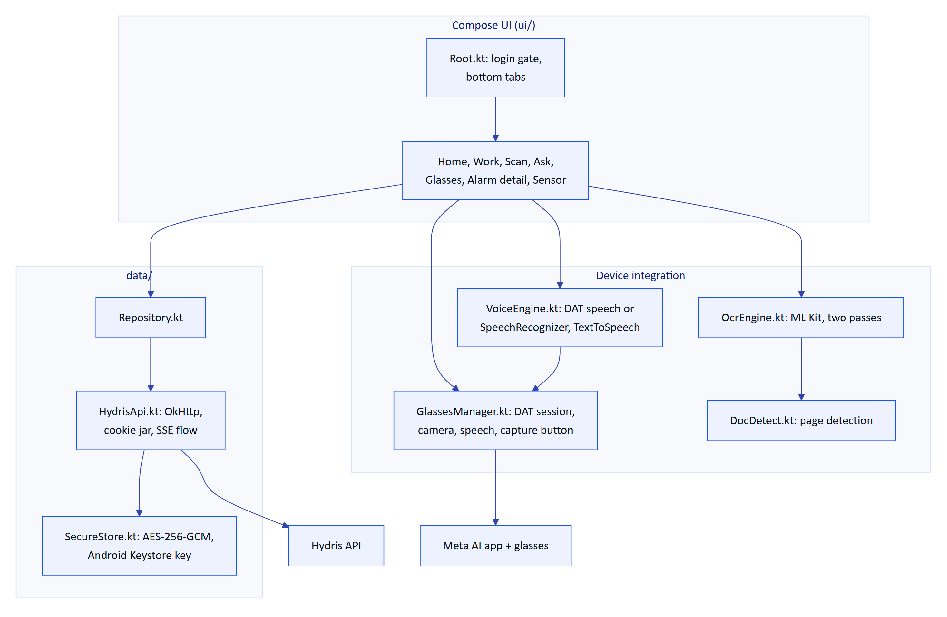
Figure 20. Hydris Field components. One API client carries two credential channels: the operator session and the paired glasses' device token.
- Sessions follow the web contract: an access token in memory and the rotating hg_refresh cookie (plus hg_demo in demo mode) persisted only as ciphertext in SecureStore. 401 responses refresh once under a Mutex and retry.
- Glasses are reached through the Meta Wearables Device Access Toolkit 1.0.1: Wearables.initialize, registration with the Meta AI app, an auto-selected DeviceSession, and the camera (preview stream and capturePhoto), speech (addSpeech) and inputs (capture button) capabilities. A debug-only mock device kit dependency supports development without hardware.
- Scans taken with the glasses are attributed to the glasses: Repository.uploadScan() uses the device channel (deviceCall) when the glasses are registered, so the console shows capturedVia: glasses and the device id.
- Server URL defaults to https://hydrisview.vercel.app and can be overridden in local.properties (hydris_url), as can the DAT application id and client token for production builds.
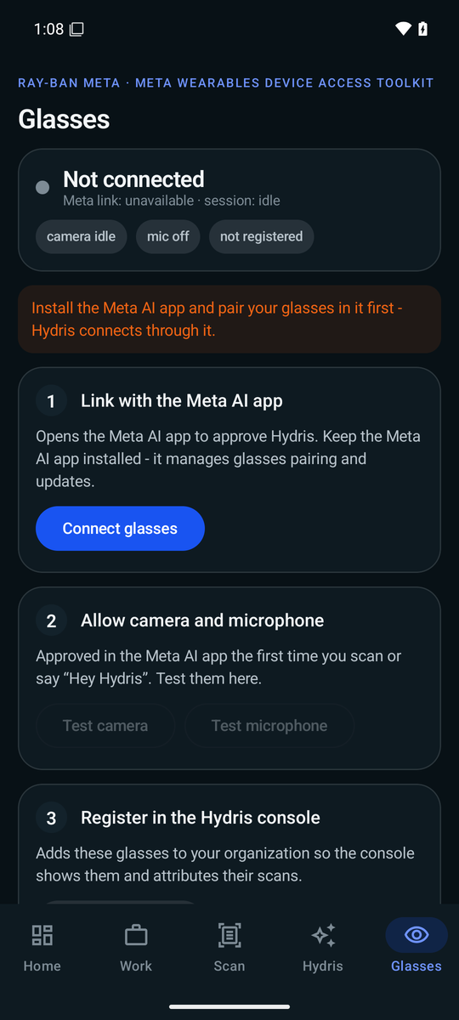
Figure 21. Hydris Field glasses screen: Meta AI registration, connected glasses and the capture and speech capabilities.
DECISION
DAT through a native app, not a WebView bridge. The first integration (apps/glasses-bridge-android) hosted the web HUD in a WebView and exposed DAT through window.HydrisNative. It works, but camera frames had to be encoded and passed across the JavaScript bridge, permissions and lifecycle were fragile, and operators need a real phone app anyway. Hydris Field calls DAT directly from Kotlin, runs OCR with ML Kit on the phone, and keeps the web HUD for the simulator, the website demo and future display glasses. The bridge remains in the repository as a fallback.

14 Deployment topologies
The same API code runs in four topologies. Configuration is a zod-validated environment (apps/api/src/config.ts): DATABASE_URL selects Postgres or PGlite, REALTIME_MODE selects the event bus, BLOB_READ_WRITE_TOKEN selects Vercel Blob over disk, and API_URL in the web app selects the external API over the built-in one.

14.1 All on Vercel (serverless)
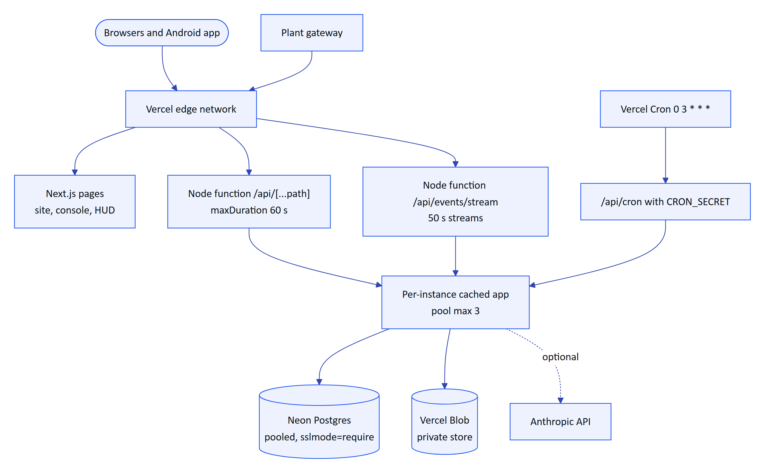
Figure 22. All-in-Vercel topology (Built, live). Pages and the API run in the same Next.js deployment; each function instance builds the Fastify app once.
- getServerlessApi() (apps/api/src/serverless.ts) builds the app on first use, caches the promise for the life of the instance, and clears it on failure so the next request retries.
- Native and WebAssembly packages (@node-rs/argon2, pg, PGlite, Fastify plugins, @vercel/blob) are declared serverExternalPackages so they load from node_modules instead of being bundled.
- Migrations run on cold start under the advisory lock unless MIGRATE_ON_START=false. The root vercel-build script would migrate during the build, but vercel.json sets buildCommand to npm run build, so cold-start migration is what runs today.
- REALTIME_MODE=db is required; the SSE route refuses to start otherwise.

14.2 Self-hosted and plant edge
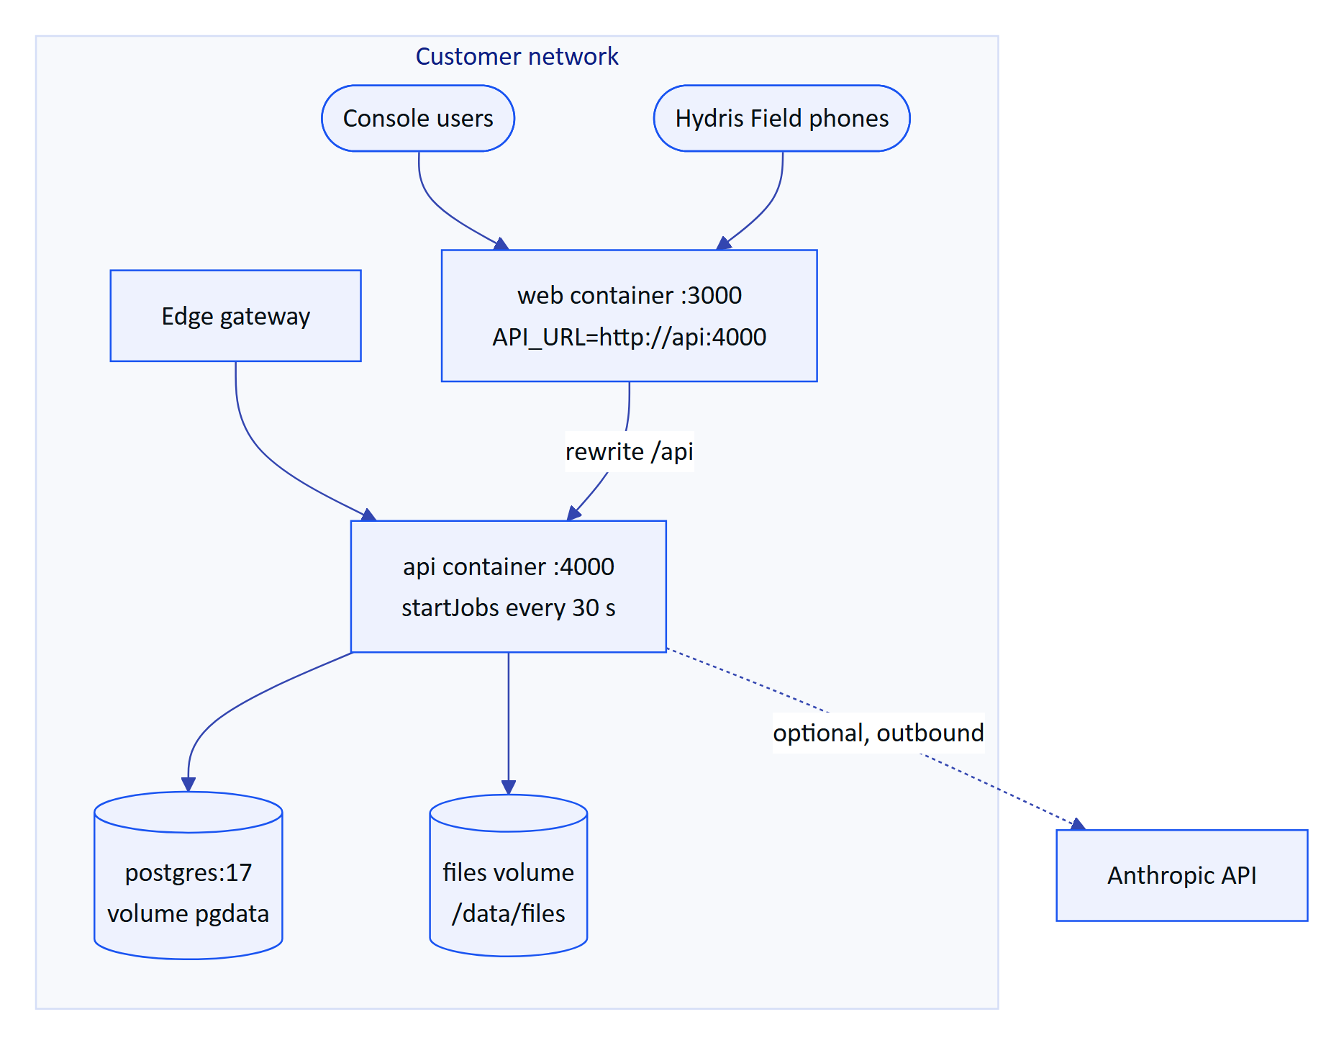
Figure 23. Self-hosted single host with Docker Compose (Built), suitable for an on-premises or plant-edge server.
docker-compose.yml runs Postgres 17, the API (apps/api/Dockerfile) and the web app (apps/web/Dockerfile, built with API_URL=http://api:4000). The API runs migrations as the owner and then works as hydris_app through SET LOCAL ROLE, so RLS applies. Memory realtime mode is enough on a single host, and the long-running jobs give 30 s stale-data detection. With no Anthropic key the system is fully functional offline from the internet except for vision enhancement and the language model assistant, which fall back as described.

14.3 Hybrid
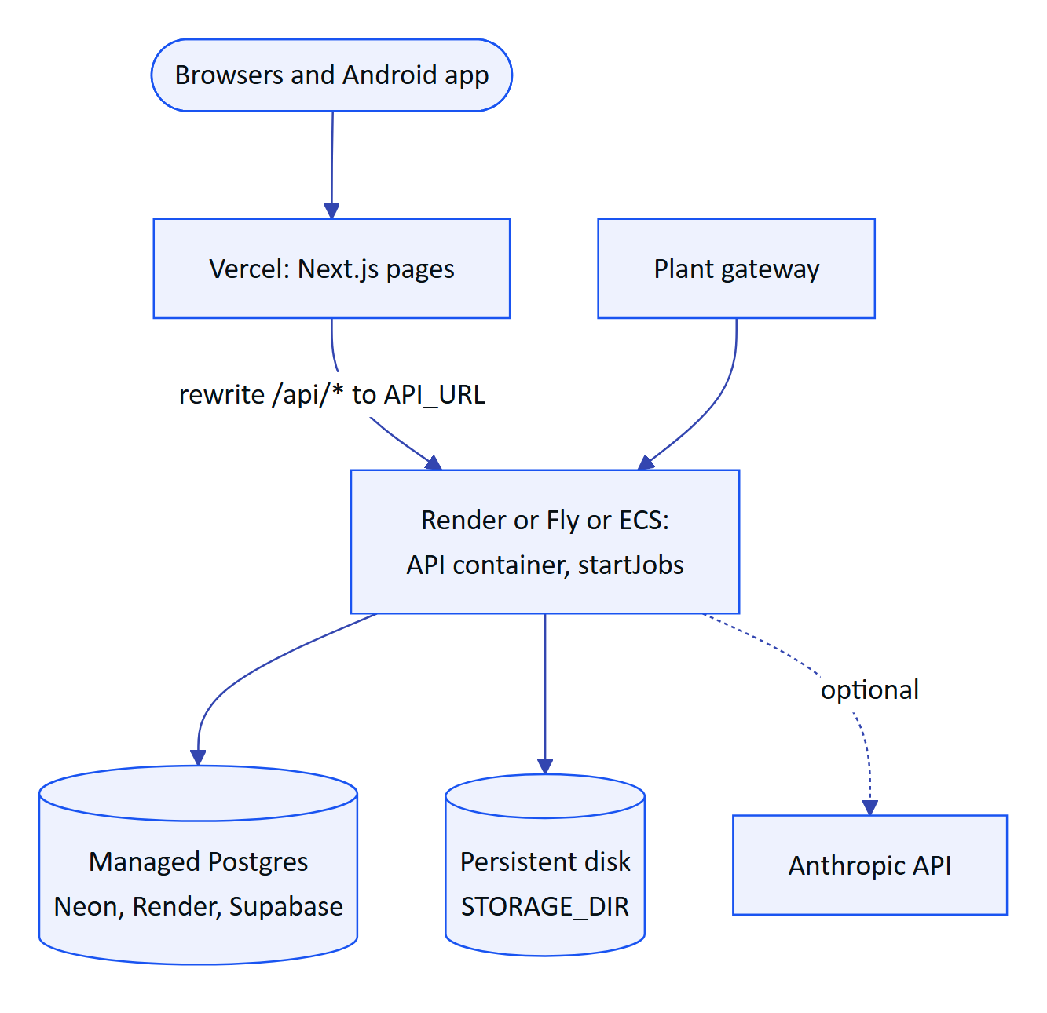
Figure 24. Hybrid topology (Partial: render.yaml exists, not the live setup). Web on Vercel, API as a long-running container next to managed Postgres.
When API_URL is set, next.config.ts adds a beforeFiles rewrite that proxies /api/* to the external API, and the in-app route handlers are bypassed. render.yaml describes the API service (Docker, health check /api/health, 5 GB disk at /data/files, generated JWT_SECRET, simulator off). This topology removes the serverless limits: memory or db realtime, 30 s jobs, no cold-start migrations, long SSE connections.
Table 14. Topology comparison
Concern | All Vercel | Hybrid | Docker Compose | Demo mode
Status | Built, live | Partial | Built | Built, live
Database | Neon Postgres | Managed Postgres | Postgres 17 container | PGlite in memory per instance
Realtime | db, 1.5 s poll, 50 s streams | memory (one instance) or db | memory | db per instance
Jobs | Cron (daily today) | Timers (30 s) | Timers (30 s) | Lazy ticker on activity
Files | Vercel Blob private | Disk volume | Disk volume | Disk in function temp
Best for | Pilots, demos, low ops | Production cloud | On-premises, air-gapped plants | Sales and evaluation

14.4 Demo mode and cross-instance state
Demo mode turns on automatically on Vercel when no DATABASE_URL is set (isDemoEnv() in config.ts). Each serverless instance migrates an in-memory PGlite database and seeds the same deterministic tenant (seed/showcase.ts). Because instances share nothing, the state that must survive a hop between instances goes through a small shared key/value store (core/demo-shared.ts).
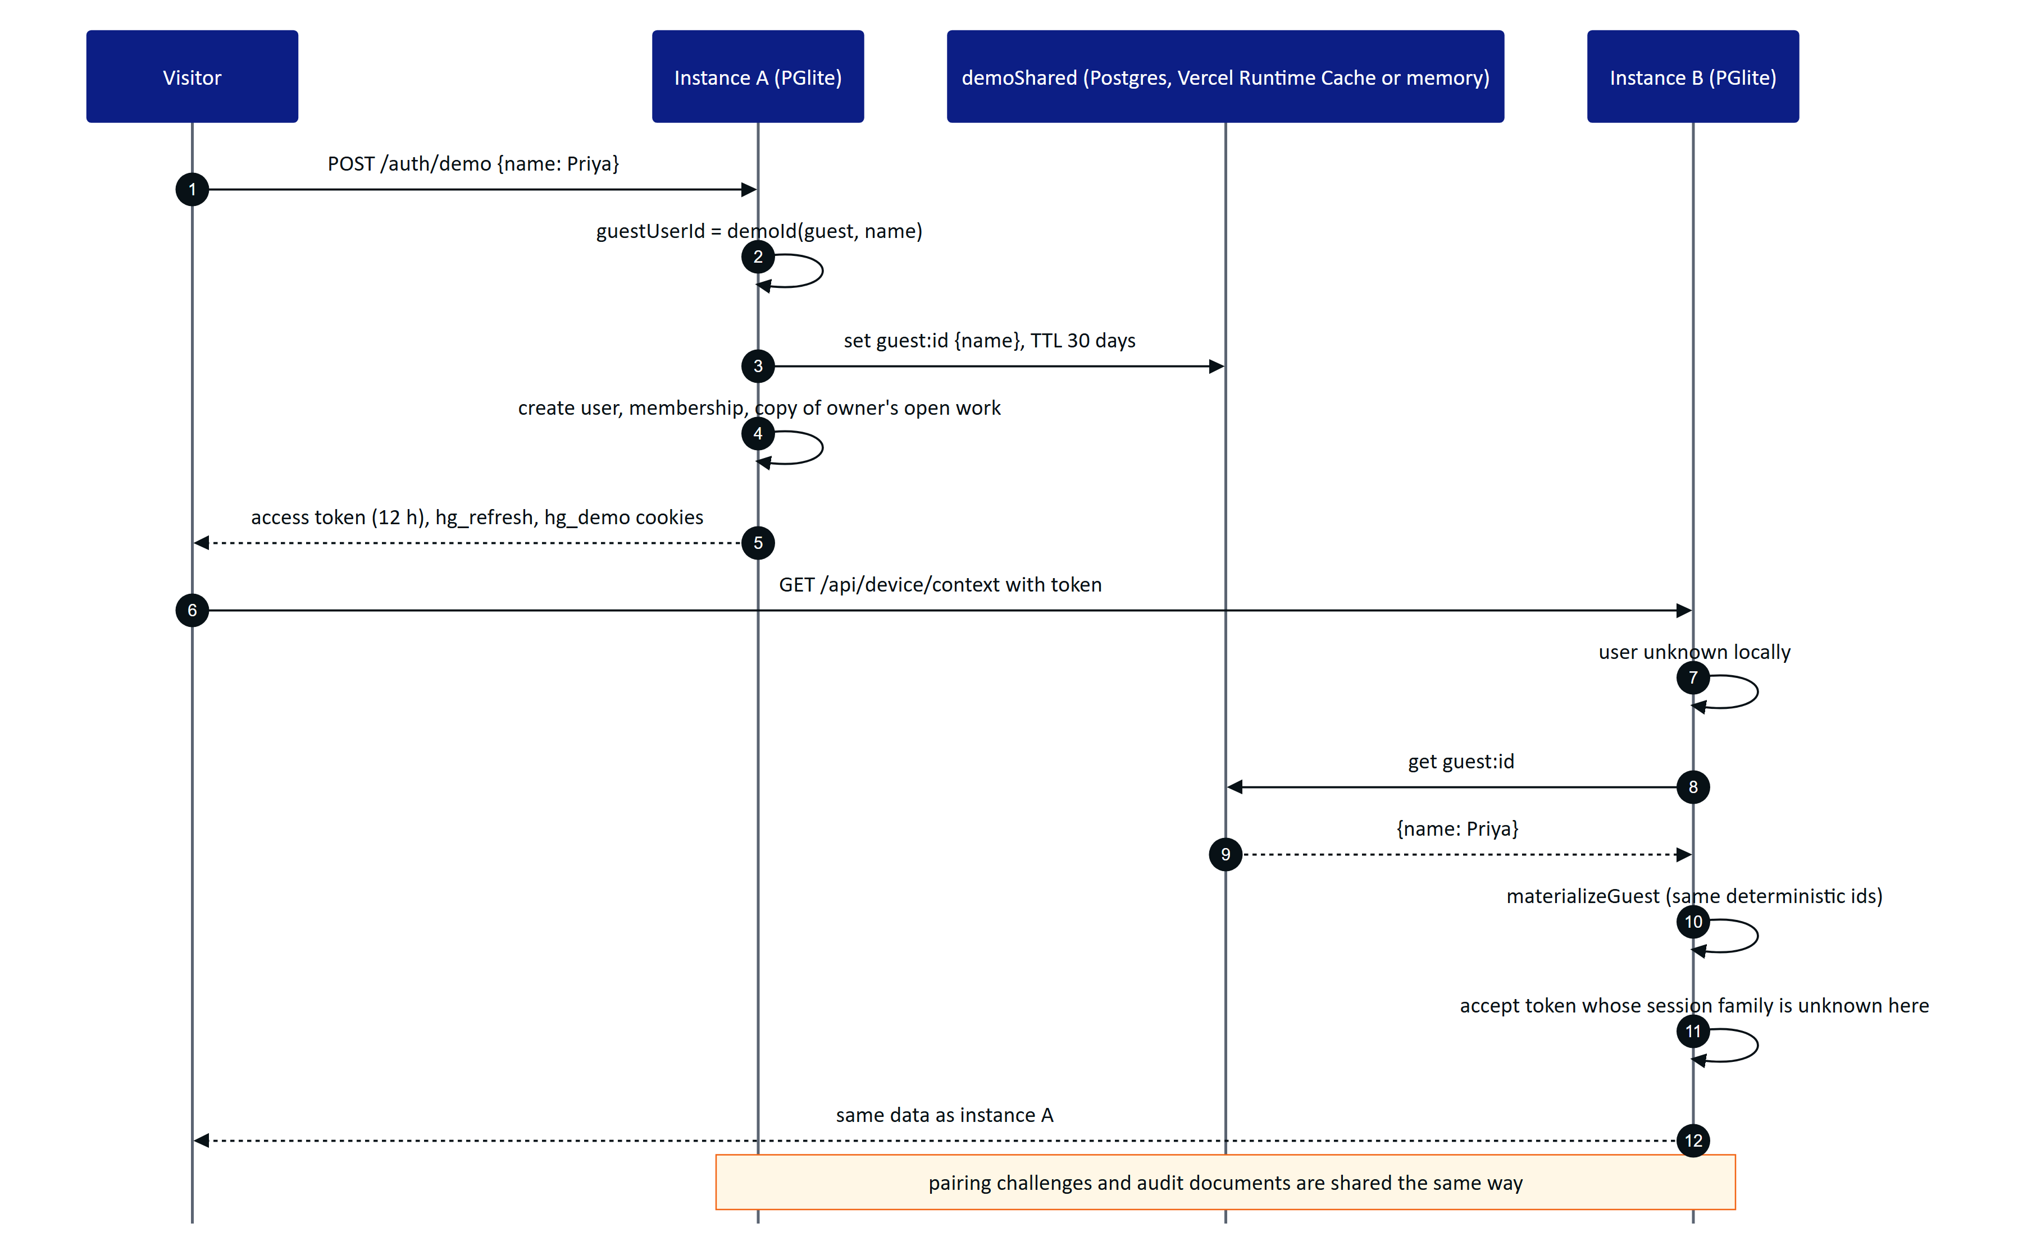
Figure 25. Demo mode across serverless instances. A guest created on instance A is rebuilt on instance B from the shared store and deterministic ids.
The shared store prefers Postgres (one table, hydris_demo_kv) when a Postgres URL is present, then the Vercel Runtime Cache, then process memory, and a Resilient wrapper falls back to memory on any error so the demo never fails because of the store. Device tokens in demo mode carry the operator and site, and demo device refresh tokens are HMAC-signed and self-contained, so any instance can rebuild a paired device. Audit documents are snapshotted into the store after each write and hydrated by revision on read.
CAUTION
Demo mode relaxes session checks (it accepts a valid token whose session family this instance has never seen) and uses public, fixed secrets. It is selected only when no database is configured or DEMO_MODE=true, logs a warning, and must never hold real plant data.

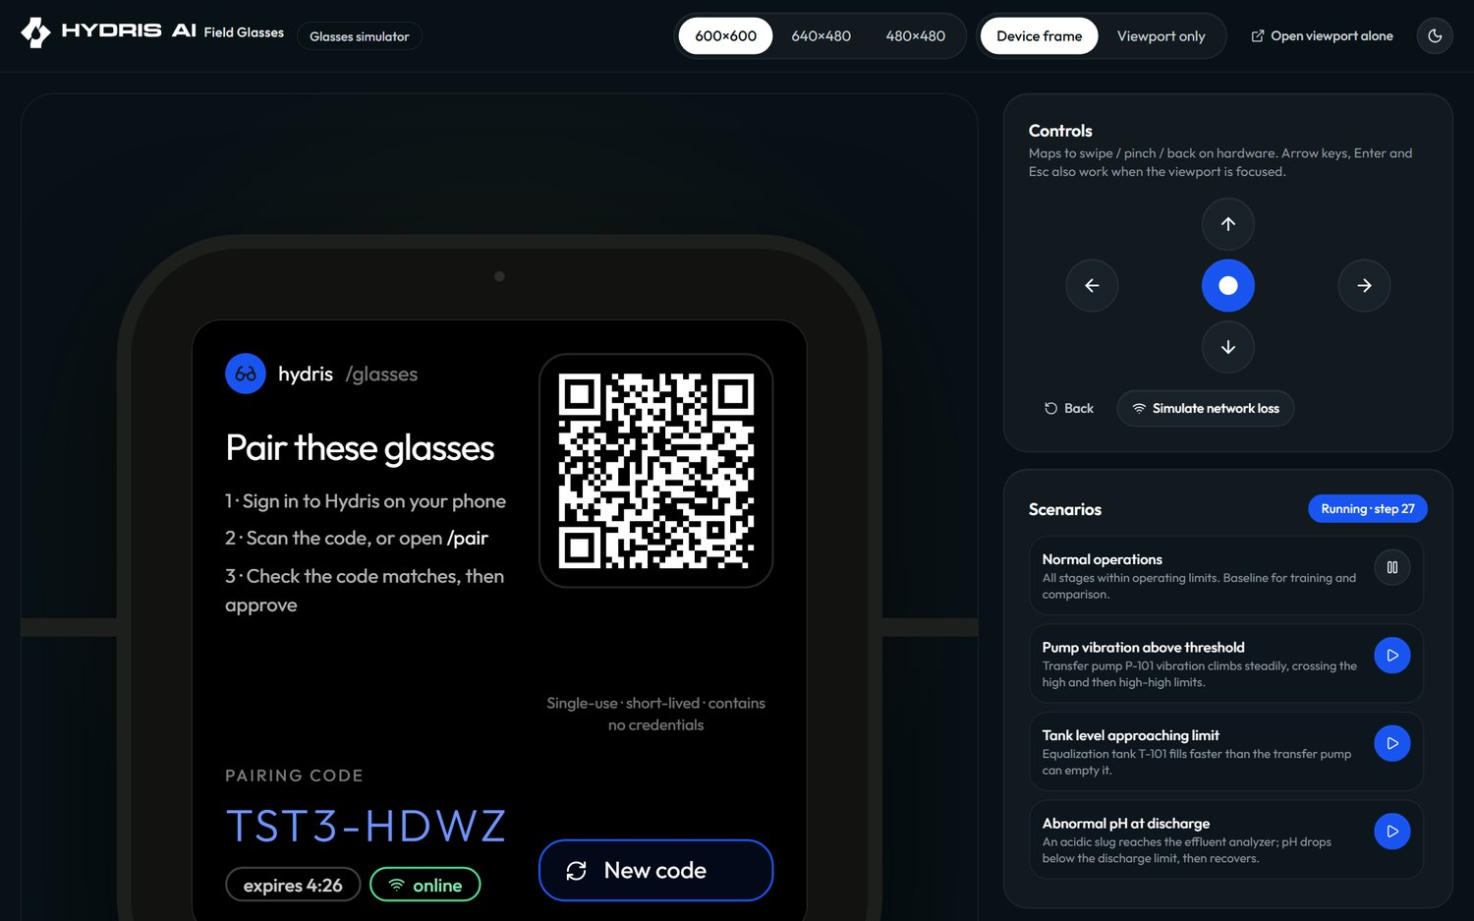
Figure 26. The browser simulator: the glasses HUD, the simulated camera and scenario controls running against the demo tenant.

15 Cross-cutting concerns

15.1 Caching and concurrency
Table 15. Caches
Cache | Scope and lifetime | Invalidation | File
Serverless API instance | Per function instance, until recycled | Cleared if the build fails | apps/api/src/serverless.ts
Effective glasses UI profile | Per API instance, 5 s | Cleared on any profile or assignment change on that instance | modules/ui-profiles.ts
Console query cache | Per browser tab | Realtime events by path prefix, batched every 1.5 s; mutations | lib/query.ts, console/Shell.tsx
OCR engine | Per page, worker created once; language data in browser cache | Never | lib/ocr.ts
Demo shared store | Postgres table, Vercel Runtime Cache (per region) or memory, with TTLs | TTL | core/demo-shared.ts

Concurrency is handled with database constraints and explicit versions rather than locks held across requests:
- Idempotent writes: readings are unique on (sensor_id, ts); inspection responses on (inspection_id, client_op_id); pairing code allocation retries up to five times on a unique violation.
- Optimistic concurrency: inspections.revision and audit_documents.revision. Audit document updates include WHERE revision = n and return 409 stale on a lost race.
- Single-flight: token refresh on every client; DemoTicker allows one step in flight and at most one step per 5 s; EventBus.flush() chains writes so batches are inserted in order.
- Serialized migrations: Postgres advisory lock.
- Connection pools: 3 connections per serverless instance and 10 for a long-running server (serverless.ts, db/client.ts).

15.2 Error handling and resilience
Table 16. Failure modes and responses
Failure | Behaviour | Where
API fails to build on a cold start | 503 service_unavailable with a short detail; next request retries the build | app/api/[...path]/route.ts, serverless.ts
Network drop on the glasses | Inspection responses queue locally and replay with client ids | glasses/link.ts
SSE disconnect | Reconnect with backoff 0.5 s doubling to a 15 s cap, resume from Last-Event-ID | lib/realtime.ts
Session revoked during a stream | session.ended, client tries one refresh, then signs out | modules/realtime.ts
Access token expired | One transparent refresh and retry | lib/api.ts, link.ts, HydrisApi.kt
Vision engine error or missing key | OCR extraction kept, aiStatus failed or unavailable with reason | modules/audit-docs.ts
Language model error or missing key | Deterministic rules engine answers | modules/voice-assistant.ts
One background job fails | Others still run; the cron report lists each job's result | jobs.ts
Demo shared store unreachable | Falls back to instance memory | core/demo-shared.ts
Event written for a rolled-back request | Harmless refetch hint | core/events.ts
Gateway sends bad readings | Per-reading rejection with index and reason; the rest are accepted | modules/telemetry.ts

15.3 Observability
Observability is basic today. Built: Fastify request logging at info level on the long-running server (server.ts) and opt-in on serverless (API_LOG=true); 5xx errors are logged with the stack; GET /api/health for load balancers and Render; the cron endpoint returns a JSON report with per-job status and duration; audit_events records security-relevant and business actions (logins, device lifecycle, alarm transitions, exports, verifications) with actor, device and IP; Vercel runtime logs capture console.error from route handlers and jobs. Planned: OpenTelemetry traces across the route handler and Fastify, metrics for ingestion rate, rejection reasons, alarm latency, SSE connections and OCR agreement, error tracking, and alerting on stale gateways.

15.4 Security architecture summary
Security is covered in depth in SECURITY_PRIVACY.md. Architecturally, the controls are layered:
Table 17. Security layers
Layer | Control | File
Transport and headers | HTTPS, helmet, frame and permissions policies | app.ts, next.config.ts
Abuse | Global 600 requests per minute plus stricter per-route limits (login 10, refresh 60, pairing 10, assistant 60, ingestion 1,200, inquiries 5 per 10 min) | modules/*.ts
Authentication | argon2id, TOTP MFA, lockout, short access tokens, rotating refresh families | modules/auth.ts, core/crypto.ts
Authorisation | Role permissions, device permission cap, site scope with 404, UI profile hook | core/principal.ts, modules/ui-profiles.ts
Data isolation | RLS with FORCE, non-privileged role, append-only grants | drizzle/0001_rls.sql and later
Secrets at rest | MFA secrets AES-256-GCM; token and key hashes only (SHA-256) | core/crypto.ts
Files | Random keys, private Blob store, served only through /api/attachments/:id | core/services.ts
Mobile | Keystore-backed AES-GCM for cookies and device tokens | SecureStore.kt

16 Architecture decision records
The decisions below are recorded here until they move to individual ADR files. Each lists the alternatives that were considered.
Table 18. Architecture decision records
ID | Decision | Alternatives considered | Consequences | Status
ADR-001 | npm workspaces monorepo for API, web, domain and Android | Separate repositories; Nx or Turborepo | Atomic cross-cutting changes; no build cache yet | Accepted
ADR-002 | Fastify modular monolith with one module per bounded area | Microservices; Next.js route handlers only | One deployable, in-process calls between modules; modules must stay disciplined | Accepted
ADR-003 | Run Fastify inside a Next.js catch-all route with app.inject | Separate API deployment only; rewrite all routes to Next handlers | One Vercel project, no network hop, same code for container mode; cold start includes app build and migration | Accepted
ADR-004 | Postgres row-level security plus application RBAC and site scope | Application filtering only; schema or database per tenant | Strong isolation with one schema; every request is a transaction | Accepted
ADR-005 | PGlite for development, tests and the demo | SQLite; Docker Postgres for tests | Real Postgres semantics (RLS, enums, date_bin) with no external service; per-instance memory in demo | Accepted
ADR-006 | Drizzle ORM with generated SQL migrations | Prisma; hand-written SQL only | Typed queries, readable SQL migrations, raw SQL where needed | Accepted
ADR-007 | Server-Sent Events over fetch for realtime | WebSockets; polling only; managed pub/sub | Works on serverless and through proxies, token stays out of URLs; polling in db mode | Accepted
ADR-008 | Two event bus modes, memory and db | Redis pub/sub; Postgres LISTEN/NOTIFY | No extra infrastructure; 1.5 s latency in db mode | Accepted, revisit at scale
ADR-009 | On-device OCR with two passes, vision model optional | Server-side OCR; vision model only | Works offline and without AI processing; vision improves layout when allowed | Accepted
ADR-010 | Meta DAT through the native Hydris Field app | WebView bridge (built first); waiting for display glasses SDK | Reliable camera, speech and button access; Android first, iOS later | Accepted
ADR-011 | RFC 8628-style pairing with short codes and poll secrets | QR containing a token; manual device enrolment by admins | No credential on screen or in a QR; works on devices without keyboards | Accepted
ADR-012 | Push-only HTTPS ingestion from an edge gateway | Hydris polling OPC UA or Modbus directly | Hydris stays outside control networks; customers or partners run the gateway | Accepted
ADR-013 | Short JWT access tokens plus rotating opaque refresh tokens checked on every request | Long-lived JWTs; server sessions only | Revocation is immediate; one database lookup per request | Accepted
ADR-014 | Demo mode as in-memory tenants with a small shared store | One shared demo database | Zero configuration, no cleanup; cross-instance logic confined to demo code paths | Accepted
ADR-015 | LLM features grounded through tenant-scoped tools, with deterministic fallbacks | Retrieval over exported data; no AI | Answers cite real readings; feature degrades gracefully | Accepted
ADR-016 | Pure domain package shared by server and web | Logic duplicated per client | One definition of state machines and rules; Android mirrors by hand for now | Accepted

DECISION
Fastify inside a Next.js route (ADR-003). The built-in API mode lets a pilot run as one Vercel project with one set of environment variables, and the same Fastify application runs unchanged as a container when a customer needs long-lived connections, frequent jobs or on-premises hosting. The trade-offs are explicit: a cold start builds the app and may run migrations, streams must end within the function budget, and in-memory state (rate limits, profile cache) is per instance.

DECISION
PGlite for development, tests and demo (ADR-005). Tests run against real Postgres semantics, including RLS policies and the hydris_app role, without Docker. The same property makes the public demo free to operate: each instance seeds its own database in memory. The cost is the cross-instance code in demo mode, which is deliberately isolated in demo.ts, core/demo-auth.ts, core/demo-guests.ts and core/demo-shared.ts.

DECISION
On-device OCR first (ADR-009). Paper records often contain personal names and signatures. Reading them on the device means the platform works without sending images to any AI provider, and the two independent passes give the reviewer a machine cross-check for free. A vision model is an opt-in enhancement, and its values are cross-checked against the OCR words inside each returned box rather than trusted on their own.

17 Quality attributes
Table 19. Quality attributes, tactics and evidence
Attribute | Scenario | Tactics | Evidence or target
Tenant isolation | A query in a handler forgets the organization filter | RLS FORCE, non-privileged role, SET LOCAL per transaction | drizzle/0001_rls.sql; covered by apps/api/test/platform.test.ts
Security | A refresh token is stolen and replayed | Rotation, family revocation, per-request family check | modules/auth.ts
Availability | One serverless instance fails to start | Lazy build with retry; 503 with detail; stateless instances | serverless.ts
Reliability of records | Network drops during an inspection | Offline queue, client operation ids, unique constraints | glasses/link.ts, modules/inspections.ts
Data integrity | Two reviewers edit one audit document | Revision check, 409 stale | modules/audit-docs.ts
Performance | An operator opens a 24 h chart | Server-side downsampling with date_bin to at most 2,000 points (default 240) | modules/telemetry.ts
Responsiveness | A critical alarm is raised | Event published in the same request; console toast on receipt | Target: under 3 s end to end in db mode (not yet measured)
Modifiability | A new screen is hidden for a role | Data-driven UI profiles, no app release | modules/ui-profiles.ts
Auditability | A regulator asks who changed a value | Append-only audit and corrections, actor and device recorded | audit_events, telemetry_corrections
Usability hands-free | Operator wearing gloves needs a value | Wake phrase, spoken short answers, capture button | voice.ts, GlassesManager.kt
Portability | Customer requires on-premises hosting | Same code in Compose; no cloud-only dependency on the critical path | docker-compose.yml
Testability | Change to alarm hysteresis | Pure functions in packages/domain with unit tests | packages/domain/test/domain.test.ts

Automated tests today: four domain test files and six API test files (about 69 test cases by count of test( calls), run against PGlite with npm test, plus a Playwright journey suite in tests/e2e/journeys.spec.ts. There is no CI pipeline yet.

18 Scalability path

18.1 Capacity model
The numbers below are planning estimates, not measurements. They assume one sensor reports every 60 s, a site has about 200 sensors and 10 concurrent console or glasses users, and the gateway batches up to 500 readings per request.
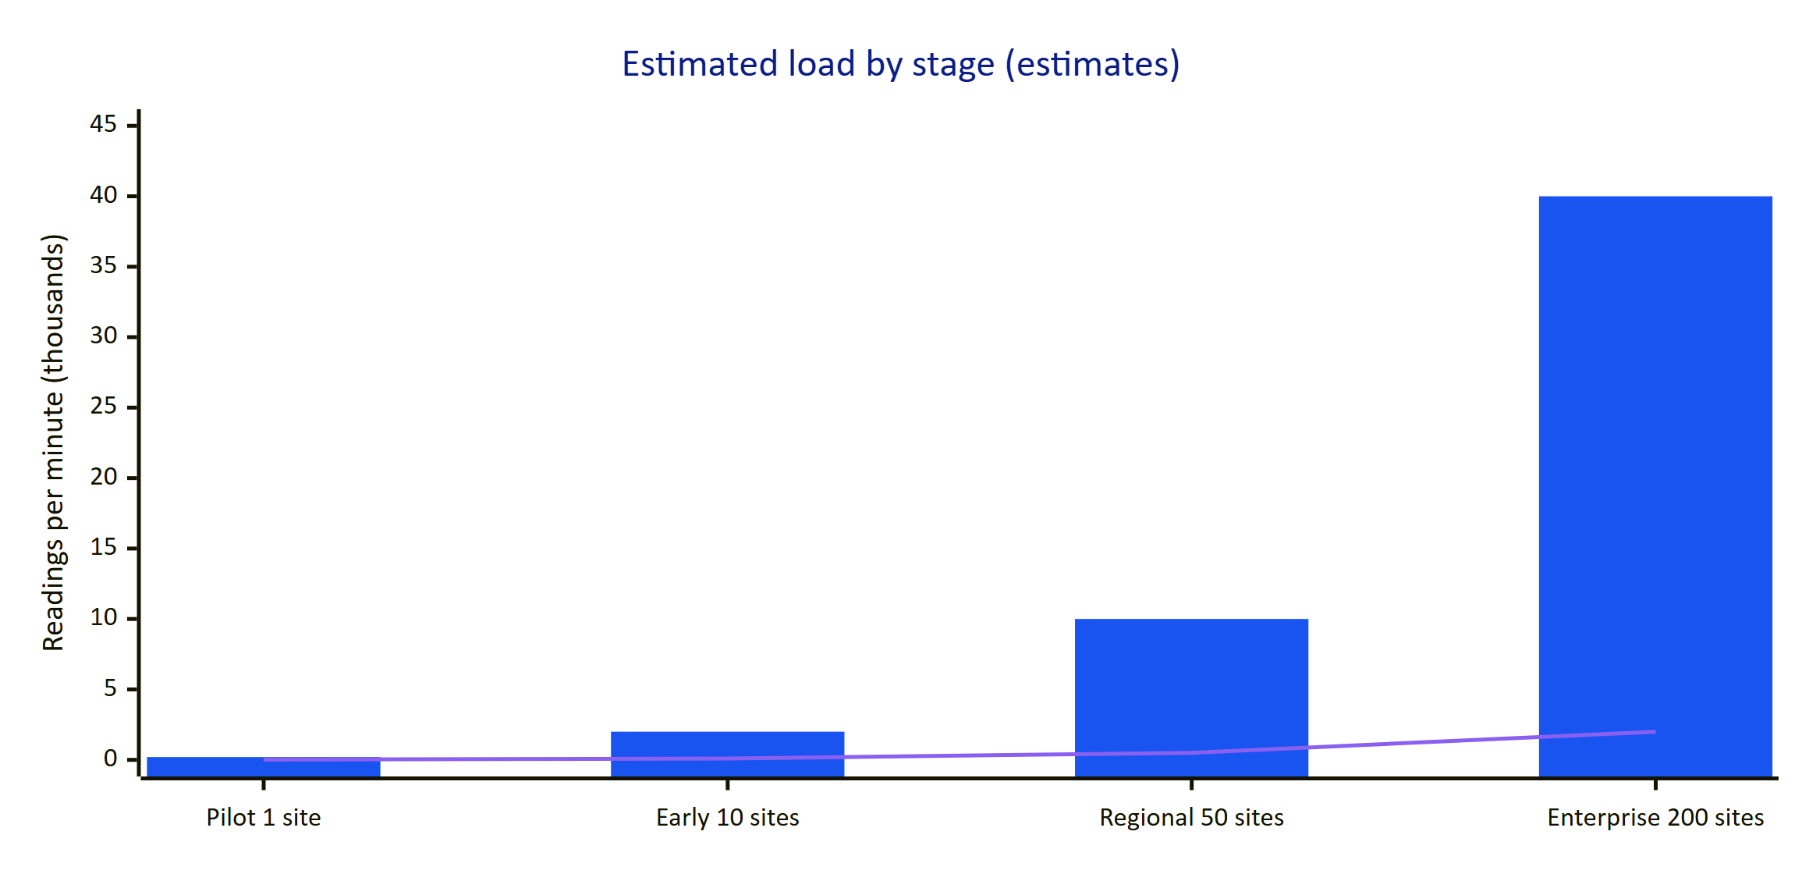
Figure 27. Estimated telemetry load and open SSE connections by deployment stage (planning estimates, not measured).
The bars are readings per minute in thousands (200, 2,000, 10,000 and 40,000). The line is open realtime connections in thousands (10, 100, 500 and 2,000). At 200 sensors per site, one site produces about 288,000 readings per day and about 105 million per year.
Table 20. Scaling stages
Stage | Load (estimate) | What holds | What must change
Pilot, 1 to 3 sites | Under 1,000 readings per minute, tens of users | Any topology. All-Vercel is fine if stale-data checks run more often than daily | Fix TD-02 (job frequency) and TD-01 (Android source in git)
Early fleet, about 10 sites | About 2,000 readings per minute, about 100 streams | Hybrid or Compose; Postgres with the current indexes | Shared rate-limit store (TD-03); move audit page images to object storage (TD-04); CI (TD-06)
Regional, about 50 sites | About 10,000 readings per minute, about 500 streams | Hybrid with 2 to 4 API instances in db realtime mode | Batch inserts and rule evaluation in ingest() (TD-11); time-partitioned telemetry and retention (TD-10); replace polling with LISTEN/NOTIFY or a broker (TD-07)
Enterprise, 200 sites and more | About 40,000 readings per minute, about 2,000 streams | Separate ingestion workers from the interactive API | Edge gateway with store and forward, MQTT ingestion, read replicas, regional deployments

The main bottlenecks, in the order they will be hit:
- Ingestion is row by row. ingest() inserts each reading and, for the newest reading per sensor, loads the sensor's rules and the open alarm for each rule. This is correct and simple but costs several queries per reading.
- db realtime polls per connection. Each open stream runs one query every 1.5 s. 500 streams are about 330 queries per second of polling on top of real work.
- Telemetry table growth. One table with three indexes and no partitioning will need time partitioning and retention well before a billion rows.
- Audit page images in Postgres. Up to 6 pages of up to 900 KB each per document, stored as base64 text, inflate the database and its backups.

19 Technical debt register
Table 21. Technical debt register
ID | Item | Impact | Severity | Proposed fix
TD-01 | The root .gitignore rule data also ignores apps/android/app/src/main/java/ai/hydris/field/data/ (HydrisApi.kt, Models.kt, Repository.kt, SecureStore.kt) | A fresh clone of the Android app does not compile | High | Anchor the rule (/data, apps/api/data) and commit the package
TD-02 | Vercel Cron runs /api/cron daily (0 3 * * *) | Stale-data alarms and pairing expiry run once a day on the all-Vercel topology | High | More frequent schedule or external trigger; or hybrid topology
TD-03 | Rate limits use the plugin's in-memory store | Limits are per instance on serverless and multi-instance deployments | Medium | Shared store (Redis or Postgres) or edge firewall rules
TD-04 | Audit page images stored as base64 text in audit_document_pages | Database and backup growth; large rows in API responses | Medium | Store in the existing Storage adapter, keep keys in the table
TD-05 | packages/contracts is empty; Android Models.kt mirrors JSON by hand | Contract drift between web, API and Android | Medium | Generate JSON Schema or OpenAPI from zod schemas; generate Kotlin models
TD-06 | No CI pipeline | Regressions found late; no automatic migration check | Medium | GitHub Actions: typecheck, unit tests on PGlite, build, e2e on preview
TD-07 | db realtime mode polls every 1.5 s per stream | Database load grows with connections | Medium at scale | LISTEN/NOTIFY fan-out per instance or a managed pub/sub
TD-08 | Email transport not wired (mail_outbox only) | Invitations and password resets need manual delivery | Medium | Provider adapter with outbox worker and retries
TD-09 | Events from rolled-back requests may be written in db mode | Spurious refetches | Low | Accepted by design; revisit with transactional outbox
TD-10 | telemetry_readings has no partitioning or retention | Index and vacuum cost at large volumes | Low now, High later | Monthly partitions or TimescaleDB, retention per tenant contract
TD-11 | Ingestion evaluates readings one by one with per-rule queries | Throughput ceiling per instance | Low now, High later | Batch insert, load rules and open alarms once per batch
TD-12 | Helmet content security policy disabled in the API; no CSP set by Next.js | Weaker defence against injected scripts | Medium | Nonce-based CSP for pages; strict CSP for API responses
TD-13 | Web HUD keeps the device refresh token in localStorage | Token exposed to any script on the origin | Medium | Native runtimes implement SecureStore; shorten web device sessions
TD-14 | UI profile cache invalidation is local to one instance | Other instances may apply an old profile for up to 5 s | Low | Accepted; or invalidate through realtime events
TD-15 | Android release build is signed with the debug keystore | Not distributable through managed app stores | Medium before rollout | Release keystore and Play App Signing
TD-16 | Comment in lib/docdetect.ts says the warp is 1240 by 1754; the default is 1654 px wide | Misleading documentation | Low | Align comment or default
TD-17 | vercel-build script is unused because vercel.json sets buildCommand | Migrations happen on cold start instead of at deploy | Low | Choose one: build-time migration with MIGRATE_ON_START=false, or remove the script
TD-18 | Observability limited to logs and the audit table | Slow diagnosis in production | Medium | OpenTelemetry, metrics, error tracking

RISK
TD-01 and TD-02 should be fixed before any pilot plant goes live: the first blocks anyone else from building the Android app, and the second means a silent gateway would go unnoticed for up to a day on the all-Vercel deployment.

20 Future architecture

20.1 Target picture
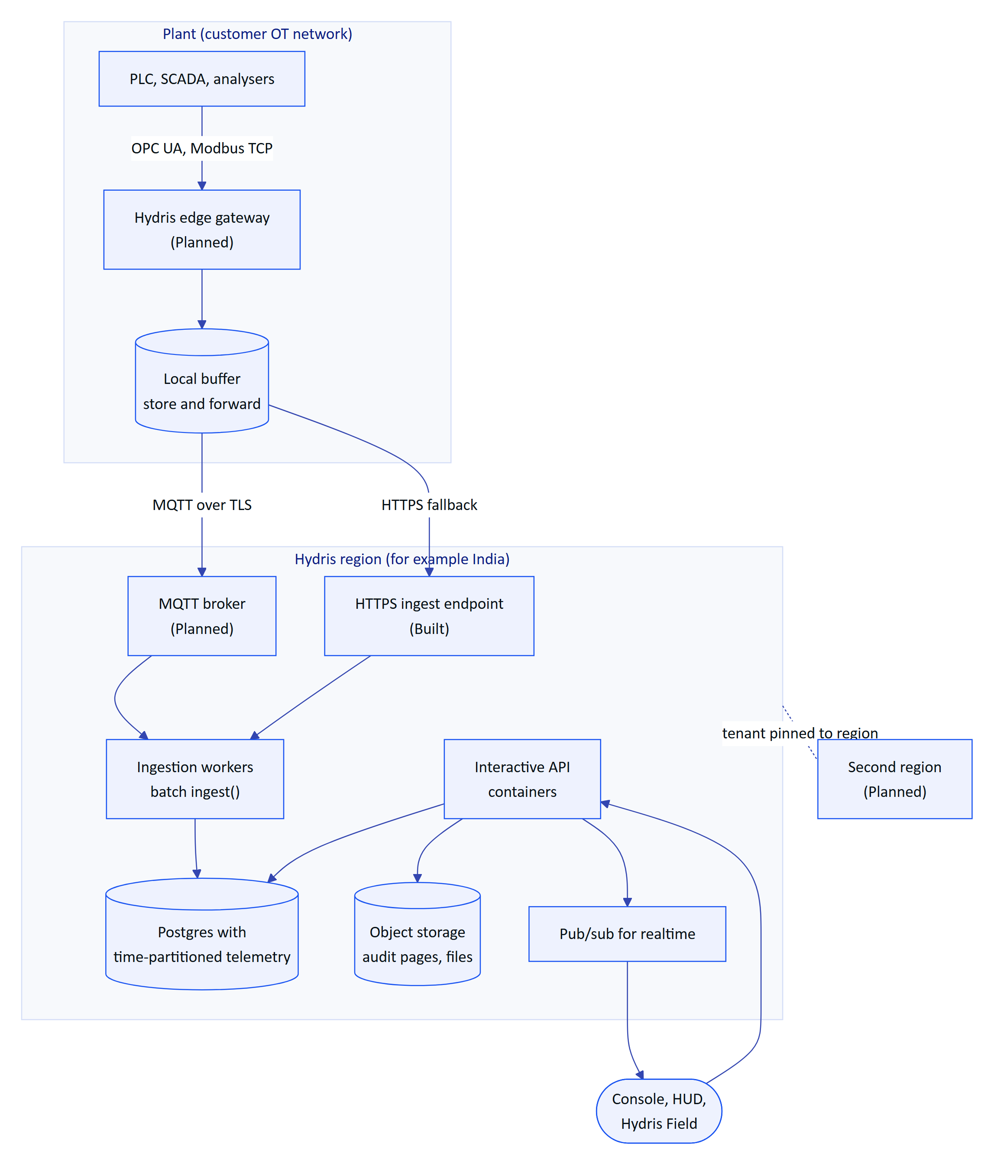
Figure 28. Target architecture (Planned). Edge collection with store and forward, a broker for high-volume ingestion, and regional deployments for data residency.

20.2 Planned building blocks
Table 22. Future architecture items
Item | Purpose | Builds on | Status
Hydris edge gateway | Read OPC UA and Modbus from the plant side, map tags to sourceRef, buffer during outages, push outbound only | POST /api/ingest/v1/readings, gateways.key_hash, sensors.source_ref | Planned
MQTT ingestion | Efficient high-frequency transport from many gateways | Same ingest() path behind workers | Planned
Batch ingestion workers | Separate write-heavy ingestion from the interactive API | TD-11 | Planned
Telemetry partitioning and retention | Keep queries fast and storage bounded | TD-10 | Planned
Realtime pub/sub | Remove polling, sub-second delivery across instances | EventBus interface already isolates the transport | Planned
Object storage for audit pages | Smaller database, cheaper backups | Storage adapter | Planned
Contracts package | One schema for API, web and Android | packages/contracts | Planned
Multi-region | Data residency (for example India for CPCB-regulated plants), lower latency | Stateless API, tenant pinned to one region's database | Planned
iOS app | Operators on iPhone | DAT iOS SDK, same API | Planned
Display glasses rendering | Native HUD on Meta Ray-Ban Display | Web HUD layouts, GLASSES_DISPLAY, UI profiles | Planned
Observability stack | Traces, metrics and alerts | TD-18 | Planned

The current design keeps these doors open on purpose. Ingestion has one entry point and an idempotency key, so a broker and workers can be added behind it. The event bus is an interface with two implementations, so a third (pub/sub) is a contained change. Storage is an adapter. Tenancy is enforced in the database, so splitting tenants across regions does not change application code. The API is stateless apart from caches that are already safe to lose.

